



**National Artificial Inteligence Strategy**

**in Lebanese Industry (2020-2050)**

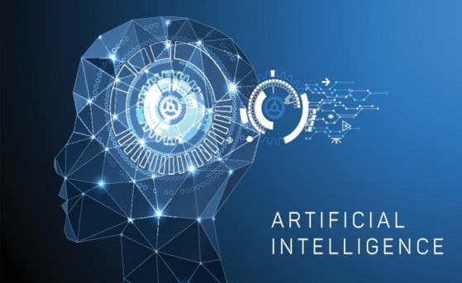

moderndiplomacy.eu

**August 2019**

Table of Contents

Strategy outline 5

1. Overviews 5

2. Industrial security 7

a. Definition 7

b. Components 9

c. Challenges 10

d. Implications of unstable industrial security 10

3. Smart Ministry of Industry 12

Introduction 16

First: Knowledge Economy 19

I. Definition 19

II. Properties and characteristics of the Knowledge Economy 20

III. Economic importance of the Knowledge Economy 20

IV. Innovation 21

1. Definition 21

2. Areas of implementation 22

3. Importance 23

4. The Global Innovation Index 2019 (United Nations Office - Geneva) 24

V. Digital economy 25

1. Characteristics 26

2. Components 27

VI. Nanotechnology 28

1. Definition 28

2. Areas of application 29

VII. Mechatronics 29

1. Definition 29

2. Main applications 31

VIII. Robotics’ future 33

Second: Artificial Intelligence 34

I. Definition 34

II. Main branches 35

1. Machine Learning 35

2. Deep Learning 35

III. AI fields 36

IV. Expert Systems Functions 36

V. AI Importance 37

VI. AI characteristics in industry: “Smart Digital Factory” 39

Third: Analysis of the Current Situation of Industry in Lebanon 42

I. The industrial sector in general 42

II. Information and Communication Technology (ICT) sector in Lebanon 42

III. Challenges facing the overall industrial sector development 43

1. Risks hindering the AI sector development 44

2. Capabilities that contribute to the AI sector development 45

IV. The Ministry of Industry 46

Fourth: The MoI’s AI strategy (2020-2050) 49

I-Vision 50

II-Mission 50

III. Strategic objectives 51

IV. Operational objectives (the eight pillars of the AI strategy in industry) 53

V. Implementation tools to achieve operational objectives 55

Conclusion 65

List of Appendices 66

References 67

# Strategy outline

## Overviews

As many countries step into the Fourth Industrial Revolution, largely driven by artificial intelligence (AI), the world witnesses fierce competition among countries in terms of studying, researching, adopting, developing and using AI for sustainable development in all economic sectors (industrial, agricultural, financial services, health, government and social), the Lebanese Ministry of Industry (MoI) was among the first ministries in Lebanon and the Arab world to develop an AI strategy for the industrial sector and other entities in various economic fields pertaining to the industrial sector.

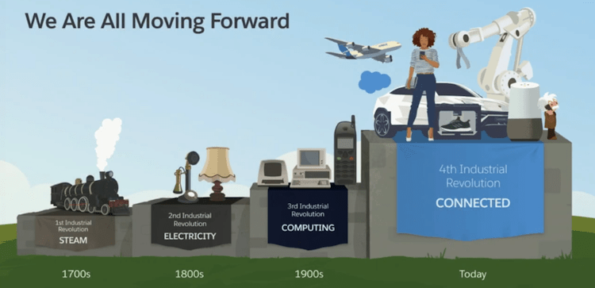

Salesforce.com

After studying several AI national strategies models in a number of countries worldwide and after conducting thorough SWOT strategic analysis of the Lebanese industrial sector’s current reality, strengths, weaknesses, challenges and opportunities in addition to a six-dimensional analysis of the external environment of the industrial sector (political, economic, social, technological, legal and environmental) to develop this sector and increase exports, we conducted a number of researches on how to help the Lebanese industrial sector enter the **Fourth Industrial Revolution**, keep pace with it, research, develop and innovate in one of its most important applications, AI in particular.

In the light of the foregoing, this strategy was developed and premised on the **Operational Objectives** of the **Integrated Vision for the Lebanese Industrial Sector (Lebanon Industry - 2025)** - launched by the MoI during the National Day of Industry on 2 June 2015- particularly the sixth objective: “**Encourage New Knowledge Industry**”.

While formulating the MoI’s AI strategy, we adopted a clear systematic methodology, starting with a historical introduction on **Industrial Revolutions** up till the **Fourth Industrial Revolution** and its most important applications (AI), followed by a definition of **Knowledge Economy**, its fields and main applications, definition of **Digital Economy**, **AI**, its main applications and benefits. Then, we presented a **Strategic Analysis** **of the Current Industrial Sector reality** as a whole (obstacles facing it) at the Lebanese **Information Technology (IT) Market** level, followed by an **Analytical Presentation** **of the MoI** (its **Initiatives, Projects and Operational Strategic Plans 2016-2020)**, to eventually cover the MOI’s AI strategy.

## Industrial security

### Definition

It is a fundamental pillar of the socio-economic security of any country.

Industrial security means providing citizens with manufactured products at suitable prices for relatively sufficient periods of time, by supporting the industrial sector and securing its sustainability through the adoption of high-quality production processes for as long as possible and in different quantities, achieving self-sufficiency of industrial consumer products, mainly those based on human added-value and raw materials produced nationally, forming a safety net by reducing dependency and the need for foreign industrial products and ensuring integration between industries to create self-sufficient and sustainable national production networks that limit waste and scarce cash needed for imports and raise the level of production and production quality.

Environment

Agriculture

Banks & Finance

Economy, Society, Politics, Education

Safe, Prosperous, Stable, Capable & Developed Country

Locally, Regionally, Globally

Sustainable Development

Construction

Works & Projects

Security & Defense

Tourism

Education

Transport & Communication

Hospitalization

Various Resources

Services

**Industry**

### Components

* Supportive purposeful policies at the governmental level (laws, decrees, economic vision, etc.) and the MoI level (Integrated Vision, Strategic Plans, programs, projects, decisions, etc.) to sponsor, protect and develop the industrial sector.
* Natural resources (agricultural crops, livestock and forestry, oil and gas, minerals, water, renewable energy, etc.) and electricity (hydro and geothermal).
* Qualified and competent human resources
* Technical and vocational schools, universities and industrial training centers to provide specialized industrial labor.
* Specialized industrial research and scientific centers.
* Areas of land classified as industrial zones.
* Local markets that consume industrial products and foreign markets for our industrial exports.
* Loans, concessional financing, incentives, exemptions and subsidies to help industrialists increase the volume of investments in the industrial sector.

### Challenges

* Absence of governmental policies, strategies and programs supporting the industrial sector.
* Lack of political and security stability
* High energy production costs, labor wages, lands prices, cost of water and environmental pollution control.
* Weak infrastructure (pollution/wastewater, energy, water, electricity, communications, roads, etc.) due to obsolescence and lack of modernization.
* Appropriate educational programs consistent with the constantly evolving industrial needs.
* Supporting societal culture.

### Implications of unstable industrial security

#### Break out of social revolutions

Any shortage in industrial products, especially food items, leads to widespread want and hunger, high poverty and deprivation levels, leading to social, political and economic revolutions and may cause the collapse of political systems.

#### Trade dependency

Trade dependency occurs when a country’s exports are highly concentrated on few metropolitan countries and its imports from such countries are larger, even double than their exports. This excessive dependence leads to the emergence of significant economic repercussions, such as a decline in the total public revenues of this country, the accumulation of public debt, permanent and large deficit in its trade balance, depreciation of its national currency and high unemployment rate, which eventually hinders the achievement of sustainable economic development objectives of the dependent country and deepens its economic dependency and downfall.

#### Food dependency

This dependency is reflected in the lack of food security when a country suffers from a significant fall in its self-sufficiency in many strategic food commodities (wheat, corn, sugar, meat, etc.), and compensates it by excessive importation from foreign producing countries. This country becomes somehow economically dependent on foreign food-exporting countries.

#### Financial dependency

In the absence of financial, monetary and economic security, the external debt of developing countries is amplified due to the continuous borrowing from countries, international banks and financial institutions in order to secure the necessary financing for their economic development, including excessive importation which leads to a critical financial dependency. Loans granted by international banks render developing countries vulnerable to economic, social and political interference. These interventions are represented at times in terms of financial and monetary measures imposed on indebted countries, at other times by changes enforced on the economic and social structure of these developing countries.

#### Expatriation dependency

It occurs when a large number of expatriates of a developing country live, work or immigrate to other countries. A number of host countries exert multiple pressures on developing countries- for political or economic purposes- such as deportation or forced adherence to host countries terms and policies.

Appendix 1: *“Economic Dependency” (in-depth and further detailed research)*

## Smart Ministry of Industry

Since 2011, the MoI has been working in a gradual, sustainable and systematic manner to upgrade its internal regulations, manage its work conditions, improve its interaction with the public, develop its central and regional buildings, increase the number of its cars for necessary commuting and inspections, update its equipment to enable the development and expansion of its data bank, provide rapid and evolving service, and link its central administration with regional departments electronically.

The MoI also endeavored to develop its website’s form and content, adopt transparency, open door policy, online requests, complaints, and communication with citizens, intensify its technical field inspections to raise the industries’ productivity and quality, increase industrial exports, open new foreign markets, expand the Lebanese market to replace imported products with similar national products and develop research capacities, statistics, studies and semi-accurate indicators to establish the Ministry and its departments as a reliable source of information, scientifically, practically and through the provision of services, develop and adopt the official templates needed for its various services (Permitting – Industrial Permits - industrial certificates - export permits - import permits, etc.) and partner as much as possible with the private sector, countries, organizations and donors to achieve the set objectives.

In implementation of its Integrated Vision, "Lebanon Industry - 2025", introduced in June 2015, comprised of eleven strategic and seven operational objectives, mainly the sixth operational objective "Encouraging new knowledge industries”, the MoI launched, early 2016, the slogan "**Innovated in Lebanon**" instead of "Made in Lebanon", to reflect the paramount need and vital importance of keeping pace with development and the Fourth Industrial Revolution, in order to ensure continuity, competitiveness and ability to meet the growing and evolving societal needs.

The Ministry has also intensified the organization of purposeful workshops, conferences and seminars, both inside and outside Lebanon, attended by its employees and external stakeholders to develop knowledge and exchange experiences, leading to:

* Setting strategic and operational plans and programs for medium and long terms in the various development fields individually or in cooperation with international organizations, foreign governments, services and related projects in the administration, including:
  + Implementation Strategic Plan for the Integrated Vision (2016-2020)
  + Operational Plans (with annual assessment) for 2016, 2017, 2018, 2019 and 2020.
  + The MoI’s Integrated and Comprehensive Strategy for Industrial Zones (IZ) and Sustainable Development 2030.
  + Lebanon’s Economy Vision (for sustainable development 2025).
  + Periodic statistical studies
  + Draft laws, developmental, protective and incentive legal texts
  + Projects of advanced international agreements for industrial cooperation, memoranda of understanding and their executive programs
  + Scientific, economic and financial research projects, etc.

Appendix 2: *A Brief Economic Report on "Ministry of Industry's Initiatives, Programs and Projects for the Implementation of the Sustainable Development Goals 2030" (expanded and further detailed research)*

* Changing the ministry’s logo into a new one commensurate with the Fourth Industrial Revolution and its main applications: Artificial Intelligence (AI), with correlated and purposeful meanings:
  + Cedar = symbol of Lebanon, homeland, history and future
  + Green = sustainable environment and green industry
  + Electronic Network = Digital Economy, a representation of the Fourth Industrial Revolution and Knowledge Economy
  + Ascending waves = emblem of AI
  + Jagged waves = advanced industry with AI
  + The waves in the cedar stem = industry, production and development, the foundations of societal structure and recovery of a prosperous economy and sustainable development of a secure and stable homeland
  + Industry at the heart of the cedar = industry, at the heart of Lebanon’s economy, is an essential pillar for survival, progress, competition and expansion.



# Introduction

Over the course of history, knowledge has always been essential for the growth of civilizations. Knowledge development helped societies’ transition from agricultural - which relied heavily on lands and labor as major contributors to the economy - to industrial societies that rely on capital, mechanization, energy, and labor as basic elements of production. In the early eighties of the twentieth century began the revolution of science and technology, this era was called the Knowledge Economy. Knowledge, creativity, innovation, informatics and technology (AI, Nanotechnology, Mechatronics, etc.) became the essential economic resources.

**Industrial revolutions throughout history**

* **The First Industrial Revolution (1750-1850):**

Emergence of steam power, manufacturing and prosperity of the textile industry.

* **The Second Industrial Revolution (1850-1960)**

Mechanical motors, steelmaking, invention of electricity and chemicals, and the use of modern technological systems such as telegraph, gas, water, sanitation and railways.

* **The Third** **Industrial Revolution (1960 - 2010)**

Its main results were Informatics and Communications Technology (ICT). Technology and information industry sector (digital electronic computer programs and applications, etc.) developed and was known as the Digital Economy.

* **The Fourth Industrial Revolution (2010- Present) (World Economic Forum in Davos, Switzerland, in 2016),**

Currently in progress and likely to produce fundamental transformations in the global economy, the Fourth Industrial Revolution is characterized by substantial inventions in AI technology, robotics, autonomous and self-driving vehicles, 3D printing, nanotechnology, digital money, biotechnology, materials science, and block chain, the advanced mechanization of manufacturing processes and the activation of "Internet of Things", "Cloud Computing" and Robotics that will shift industries to the so-called "smart factories".

Third Industrial Revolution

**1960-2020**

***Mechanical Engines***

**(Invention of Electricity)**

**Mass Production**

Mass production

Second Industrial Revolution

**1850-1960**

***Steam Power***

First Industrial Revolution

**1750-1850**

***Knowledge Economy***

(Research - creativity - innovation - intellectual production - (Digital Economy, ICT - Computer software and applications, etc.)

Internet of Things and Big Data - Cybersecurity - Biotechnologies

**Artificial Intelligence**

Fourth Industrial Revolution

**2010- Ongoing**

# First: Knowledge Economy

## Definition

It is the economy that focuses on obtaining, participating in, developing, innovating and employing knowledge, with the aim of improving the quality of human life in all its fields by providing valuable information services and advanced technological applications through the use of the human mind as knowledge capital and activation of scientific research to create a set of strategic changes in the national economy in order to develop it and help it keep pace with the challenges of the new globalization system, ICT and sustainable development.

The Austrian economic scientist Peter Drucker was one of the first to use the term Knowledge Economy as the title of chapter 12 in his book "The Age of Discontinuity” (1969), that Drucker attributed to economist Fritz Machlup from the sixties, originating in the idea of “scientific management” developed by Frederick Winslow Taylor.

Appendix 3*: “Knowledge Economy” (an in-depth and further detailed research)*

## Properties and characteristics of the Knowledge Economy

* Creativity and innovation in science and technology
* Rapid spread and transmission of information through the new globalization system based on the ICT revolution
* Intangible intellectual assets such as inventions, studies, research, creative ideas, etc.
* Respect of intellectual property rights
* Using digitization to transfer intellectual assets
* Using electronic networks to enter the virtual world (internet world)
* The added value of the knowledge economy decreases with the transfer of intellectual assets (such as inventions, studies, research, creative ideas, etc.).

## Economic importance of the Knowledge Economy

This new economy represents a promising and steady future opportunity for Lebanon. It must be used to achieve prosperity for the Lebanese economy, increase domestic output growth, find appropriate solutions to the economic crises facing Lebanon which increased youth unemployment rate to nearly 30% (World Bank 2016), in addition to amplified poverty rate and a fall in economic growth rate from 10% in 2010 to nearly 1.2% in 2016 and 0.3% in 2018, in addition to rising public debt value, which amounted to more than 85 billion dollars in 2018.

## Innovation

**"Companies must innovate or die”**

### Definition

Innovation is the creation of a new thing, path, idea, concept, method, product, service, or discovery that didn’t exist before, or the development of something that already exists by reformulating, reproducing, or restructuring it in completely different new ways.

Creativity and innovation are one of the key fundamentals to manage, sustain, and safeguard businesses and enterprises, but also to help solve their problems and keep pace with development.

Appendix 4: *“Innovation for Sustainable Industrial Development” (an in-depth and further detailed research*)

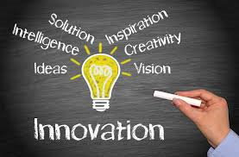

userresearchinstitute.com

### Areas of implementation

* All branches of science (medicine, sociology, economics, etc.) and technology
* Industry, trade and tourism Sectors
* Means of teaching and education
* Media
* Intellectual output
* Ideas, trends, analysis, culture and entertainment
* Arts in general
* Other fields (environment, energy, banking and financial services, agriculture, etc.)



### Importance

* Improvement of development and economy
* Raising the level of production, increasing product competitiveness, diversifying products and creating jobs
* Increasing national income and raising the level of national wealth
* Increasing production efficiency through reduced costs, rationalized use of raw materials and various resources needed for the production process.
* Achieving sustainable production and consumption in order to implement the sustainable development goals (SDGs).
* Opening new horizons (new markets, investment opportunities, innovative products, greater diversity, etc.) and different capabilities (resources, added value, savings, alternatives, etc.)

### The Global Innovation Index 2019 (United Nations Office - Geneva)

* **Lebanon ranked 88th**

**Top innovation economies:**

1- Switzerland

2- Sweden

3- The Netherlands

4- United States of America

5- United Kingdom

UAE: ranked 36th globally, Kuwait: ranked 60th globally.

## Digital economy

It is considered the basis of the Knowledge Economy infrastructure and depends on information technology in every stage of the ICT industries. Speedy and large-scale progress in digital electronic technology - particularly digitization, where diverse forms of information, such as image, voice, etc. are converted into a single binary code (ones and zeros or computer code) then sent via telephone lines or airwaves- contributed to the creation of the Digital Economy.

Appendix 5: *“Digital or Virtual Currencies”, an extensive and further detailed research.*



### Characteristics

* Relies mainly on human intelligence for programming, analysis, deduction and development of alternatives.
* The main cost lies in Research and Development (R&D).
* Digital air, which provides free access and use of the internet in any geographical location within its scope
* Digitation (information, communications, transactions, commodities, messages, books, etc.).
* Working within the virtual world (video conferences, electronic government and ministries, companies, schools, markets, universities and others).
* Digital networking between individuals, governmental establishments, entities, ministries, international organizations and governments.
* Providing smart products (intellectual assets, scientific research, computer programs, digital applications and others).
* Email, web, digital money, electronic checks and electronic signature.
* Networking process that provides abundance of information in addition to securing the media provided by networks.

### Components

* Digital administrative work (digital programs, correspondence, files processing, archiving and storage, etc.).
* E-commerce/digital commerce (buying and selling through virtual e-commerce centers).
* E-business intermediation, buying and selling over the Internet through virtual intermediaries.
* Electronic banks (managing financial accounts and banking business through virtual banks' websites).
* Electronic Accounting (using digital/electronic software for auditing and accounting).
* Electronic control (using digital programs to carry out surveillance, monitoring, follow-up works, etc.).
* E-government, a virtual version of the real government, except that the former functions through networks, information systems and technology and mimics the functions of the real government that operates through tangible government’s entities. It provides various government services through electronic media and technology tools, mainly internet and communications.

## Nanotechnology

### Definition

As defined by the US National Nanotechnology Initiative: Nanotechnology is the understanding and control of matter at the Nano scale, at dimensions between approximately 1-100 nanometers, (often compared to human hair, which is 80,000 nanometers in width) where unique phenomena enable novel applications, encompassing nanoscale science, engineering, and technology and involves imaging, measuring, modeling, and manipulating matter at this length scale.

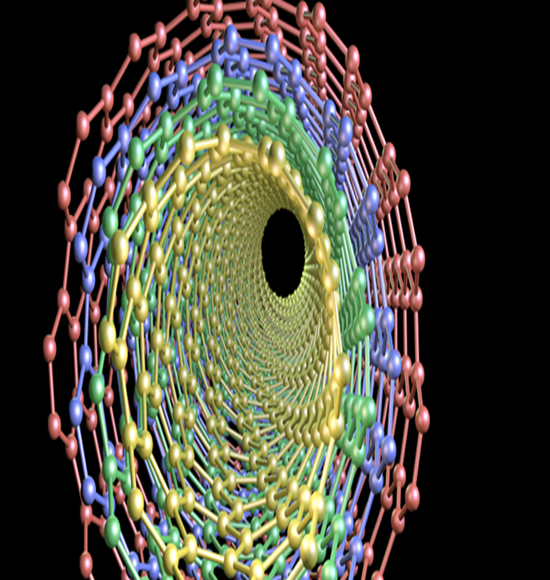 Appendix 6: *“Nanotechnology”, an extensive and further detailed research)*

### Areas of application

* Biotechnology - mechanical engineering and robotics - information technology - energy and environment - aviation - transportation - food and agriculture - national security and weapons - fabrics - medicine and health - physics - chemistry - life sciences, etc.
* Nanotechnology is basically a set of technologies that allow manipulation of the matter properties on a very small scale and can have many applications in multiple fields.

## Mechatronics

### Definition

Mechatronics is a multidisciplinary branch of engineering that combines mechanical, electrical, robotics and electronics engineering. Mechatronics focuses on designing products that have both mechanical and electronic components, as it plays the role of coordinator and control system between the two branches.

* Mechatronic systems are sometimes called smart devices, because they are supposed to simulate human thinking, but they are based on abstract and purposeful programming.
* Today, Mechatronics are introduced into most devices, in robots and factories; it is found in autopilots for instance and other fields.
* An industrial robot is a prime example of a mechatronics system; it combines aspects of electronics, mechanics, and computing. Technical and scientific evolution history shows that the first industrial robot invention was actually intended for industrial purpose, i.e. provide assistance to human workers in the industrial sector. History records that the first industrial robot effectively used in a factory was produced by General Motors Company in 1961. The robot was called “UMINATE”, and was used for the first time at the company’s factory in New Jersey, USA.

Appendix 7: *"Mechatronics" (an extensive and further detailed research)*

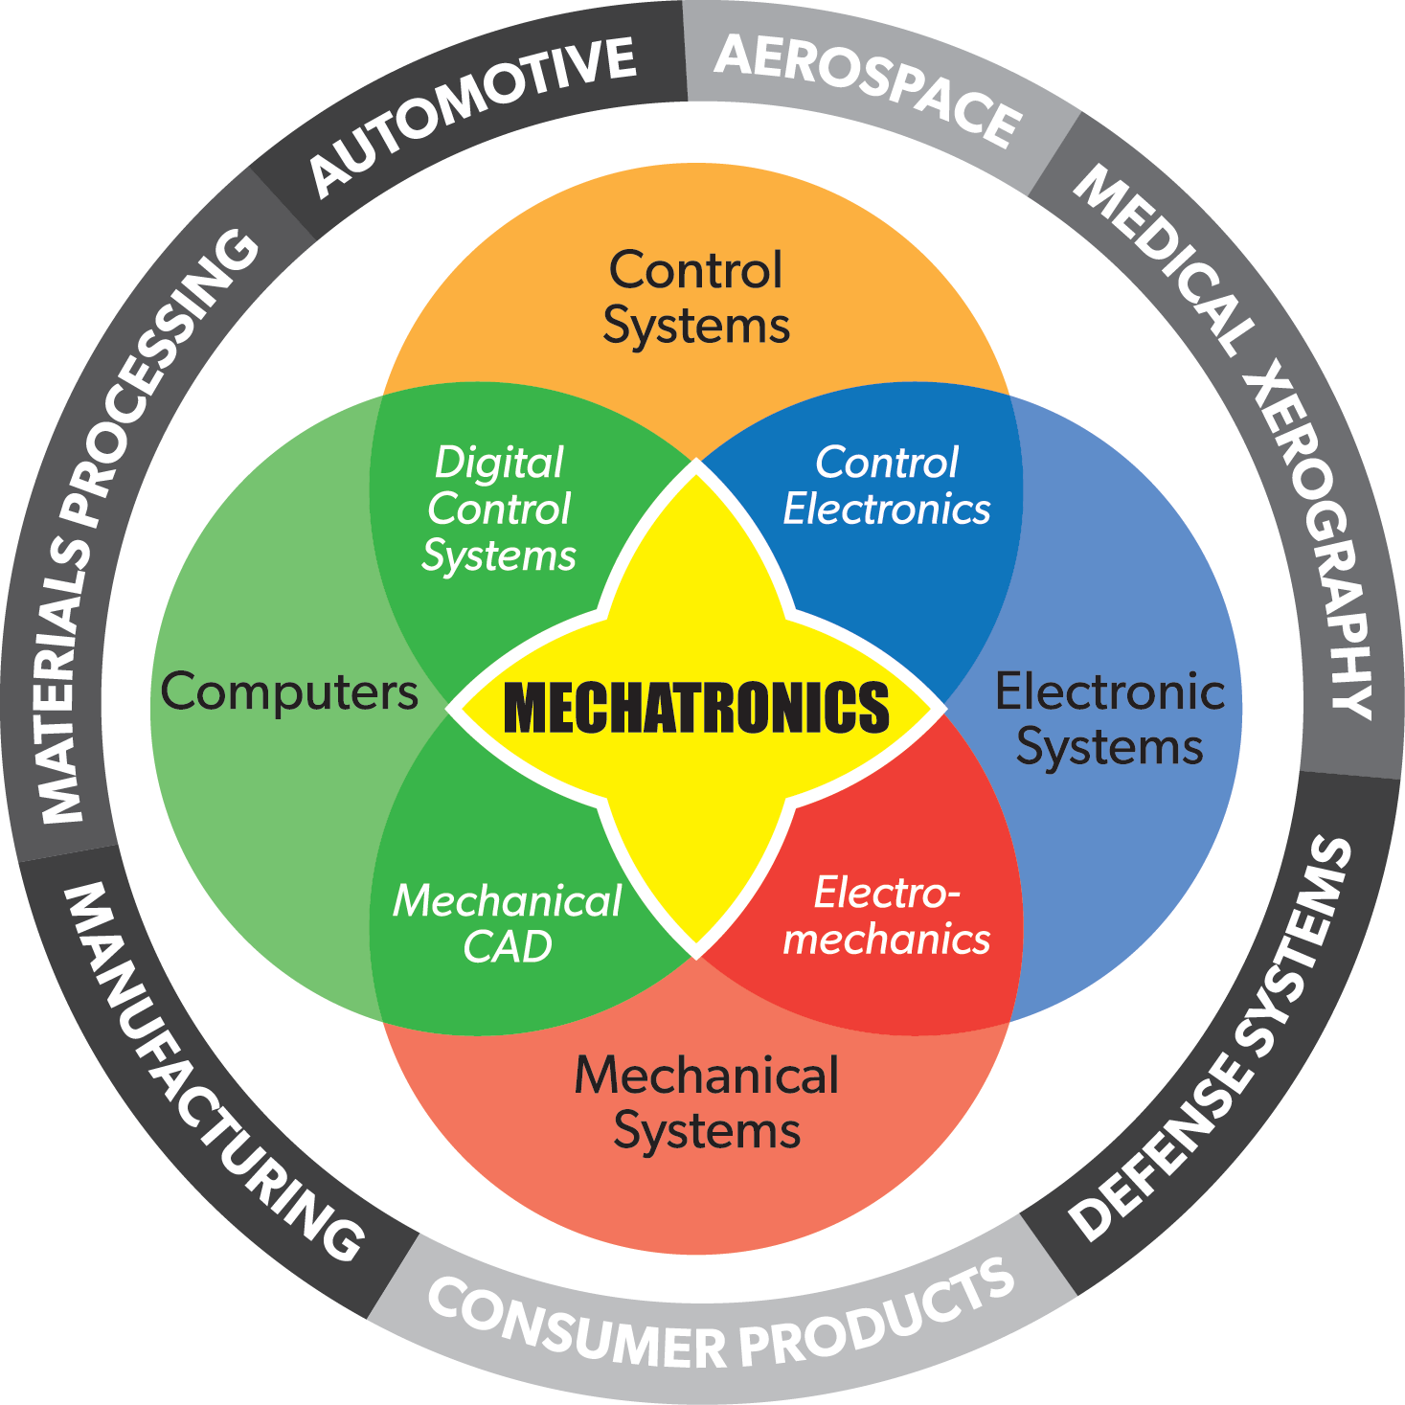

Southflorida.edu

### Main applications

* Supervisory control machinery and equipment, deriving data and products.
* Engines, automotive engineering and automatic equipment
* Computerized control systems such as screening machines
* Computer engineering and designing of gadgets such as computer disks, a branch of engineering, combining multiple fields of computer science and electronics engineering required to develop computer hardware and software.
* **AI’s Expert systems**, computer programs that use artificial-intelligence methods to solve problems within a specialized scientific domain that ordinarily requires human expertise
* An expert system relies on two components: a knowledge base and an inference engine.
* A **knowledge base** is an organized collection of facts about the system’s domain.
* An **inference engine** interprets and evaluates the facts in the knowledge base in order to provide an answer. Typical tasks for expert systems involve classification, diagnosis, monitoring, design, scheduling, and planning.
* **Computer-integrated manufacturing (CIM)** is the manufacturing approach of using computers to control the entire production process. This integration allows individual processes to exchange information with each other and initiate actions; manufacturing becomes faster and less error-prone.
* **Automation**, part of Robotics, designed with the use of specialized computer programs (with the great technological progress that the world witnessed during the industrial revolutions and the subsequent development and advancement of machinery and equipment, the so-called concept of automation appeared, where machines replaced human workers in operations).
* **Transport and Communications Systems**, use of the latest technology in computers, electronics and communications to overcome the challenges obstructing land, sea and air transport. These systems are intended to raise levels of safety and productivity, facilitate and improve general transport movement. Particular attention is given to the use of these advanced technologies in the management of information related to the performance of transportation facilities -airports, ports, paved roads or trains- by robots and electronics; information can also be obtained by means of terrain, weather, environmental conditions, or even collision accidents.
* **Mobile Phone Applications**, programs that run on smart phones, relying on a number of options offered by these phones to provide a specific service to their users, and mostly rely on electronic motors, computers, giant memories, and internet connection provided by these phones.
* **Medical Imaging Systems**, by using computers and digital image processing techniques, and the production of medical images and practices.
* **Computer Vision** that helps manufacturers work safely, intelligently and effectively in various ways. Predictive maintenance is an example of the various applications used in this field, through which equipment and machinery are monitored to interfere before malfunctions cause a total and costly breakdown of the devices. The computer vision also monitors packaging operations and product quality, in addition to monitoring and disposing of defective products before they reach the final stages of the production process, which contributes to reducing costs.

## Robotics’ future

* **Automated Control Systems** (developing machines that can replicate humans thinking and actions)
* **Sensing and Control Systems** (have many uses in agriculture for instance: such as predicting the quantity and amount of agricultural crops, the amount of appropriate and sufficient water for irrigation, the need to treat plantations and rationalize the use of different resources, etc.
* **Surgical Robots** that perform surgeries via remote feed
* **Rehabilitation of Robots** (reprogramming and repair of robots)
* **Underwater and Space Robots**: use robots to explore space and underwater
* **Monitoring and Follow-up Systems** to verify, treat and facilitate intervention when needed.
* **Learning and Teaching Machines** (robots that act as teachers and instructors)
* Large-scale **Intelligence and Military Operations**, particularly in the fields of space, aviation, drones, missiles, monitoring and detection equipment, microfilming, wiretapping, movement, advanced weapons, etc.
* **Robot Rights and Robotics Ethics** (robots are subject to governing laws) in addition to many other future fields of robotics.

# Second: Artificial Intelligence

## Definition

 Computer systems intended for the production of artificial intelligence with the intellectual processes characteristic of human intelligence, in a faster and more accurate manner. AI is used for decision-making in specific fields. The machines are enabled to carry out the tasks that need human intelligence during its functioning such as logical reasoning and the ability to make changes.

AI is a scientific system launched as an individual research in 1956 at Dartmouth College in Hanover, USA, during a summer school organized by four American researchers: John McCarthy, Marvin Minsky, Nathaniel Rochester and Claude Shannon. Since then, the term "artificial intelligence" has spread.

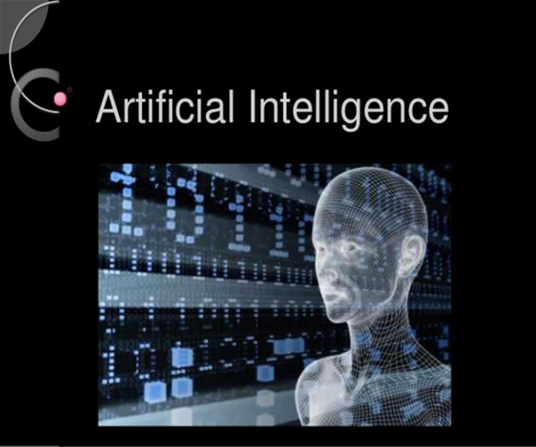 

## Main branches

### Machine Learning

It is one of the main AI applications that developed greatly. It was called machine learning because it focuses on the development of computer programs that can access data and use it to “learn” for themselves at two levels, inductive and deductive:

* **Inductive learning** draws general rules and provisions from large data
* **Deductive learning** is based on general provisions and applied in specific instances.

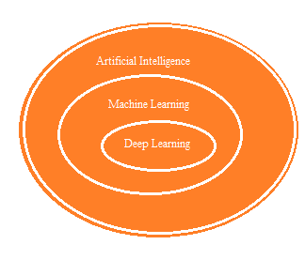

### Deep Learning

It is a branch of machine learning; the computer tests logarithms and programs and learns to improve and develop them on its own in order to perform difficult tasks that require a deep understanding of the data and the nature of its work (for example: diagnosing diseases using medical imaging).

(Photo: MOI-BJ-2019)

## AI fields

* **Deeply Independent Robot Technology**
* **Natural Language Processing**, a sub-science of AI, which in turn branched from informatics; it interferes greatly with linguistics that provides the required linguistic characterization of a computer. This science enables us to create softwares that can analyze and simulate the understanding of natural languages.
* **Simulation Models**, a method or educational method generally used by teachers or trainers to bring students closer to real world scenarios, that can’t be easily provided due to high financial costs or qualified human resources (learning to fly a plane, etc.).
* **Expert Systems**, a smart software program based on the use of knowledge and inference steps to provide solutions to problems that needs experts’ advice to be solved.

## Expert Systems Functions

* **Planning**: by using the available information and capabilities to predict and prepare for the future, and arrange the appropriate conditions.
* **Decision Making**: from available options according to existing or expected capabilities.
* **Control and identification of deviation**: by following-up on implementation, anticipating gaps, weaknesses and intervention for appropriate treatment.
* **Diagnosis of deficiency**: or invalidity before or immediately after it occurs to speed up treatment and intervention to correct the course
* **Interpretation training:** to provide data as much as possible to clarify a particular situation and facilitate finding solutions.
* **Time saving:** by quickly analyzing, inferring, and using stored information.
* **Making solutions**: by providing the organization or enterprise with solutions consistent with the expertise gathered from available information and previously known cases.

## AI Importance

* Preserving the accumulated human experiences by transferring them to robots and computers
* Using human languages to deal with machines instead of software languages
* Diagnosing diseases and prescribing appropriate treatments
* Legal, professional, economic and social consulting
* Interactive education
* Security and military fields
* Decision-making (judiciary, for example)
* Carrying out rescue, intervention and research operations
* Participating in scientific research.
* **Automation**: is a term given to mechanical and electronic machines, equipment and installations that operate without human intervention (industrial automation, for instance), a process that makes factories more dependent on machines rather than humans. Automation aims to increase production as machines can work faster and more accurately than humans by hundreds of times, consequently, at a lower, more rationalized costs and consistent production.

## AI characteristics in industry: “Smart Digital Factory”

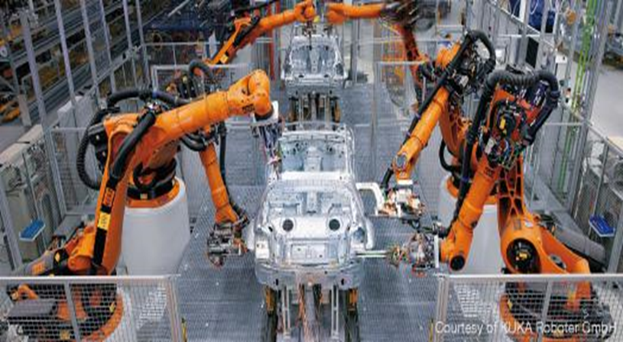

Since the early twentieth century, factories had rows of workers performing one single task repeated throughout the day, even after the emergence of robots in manufacturing operations with the first operating industrial robot, Unimate, in 1962 at General Motors. Currently, reality can be depicted as follows:

* The application of AI in factories requires the presence of interconnected networks, capable of receiving data from production lines, design and engineering teams and from the quality control department to form an integrated smart process, where the correct smart devices must be placed in the correct data collection points for the success of the process and the achievement of goals.
* In the smart digital factory, the human element interference is very limited, where humans merely simulate machines, control, and inspect goods manufacturing but does not produce such goods. Industry automation is already depending on operating robots (mainly in Germany and China).
* Future factories will turn into digital companies to maintain their competitiveness with reduced AI costs which will contribute to raising the efficiency and quality of production.
* Robots-operated factories that are programmed to work independently.
* The AI will allow sensor devices to detect defects in the production line, which will be sent to Cloud Computing containing the product properties to verify this information, and then take a decision to immediately withdraw the defected part from the production line.
* Manufacturers will save large amounts of money not only by improving the production process, but also by saving the trouble of withdrawing defective products from the market.
* AI will become essential in assessing opportunities and forecasting future orders, which will reduce costs to factories; producers will be able to increase their sales value to develop and produce innovative products tailor-made to each individual customer.
* AI applications will play a pivotal role in increasing production volume, accuracy of its products and reducing costs.
* Most predictive maintenance systems rely on machine learning technology to formulate forecasts in factories to conduct maintenance by using algorithms to predict the next failure of production systems, through the following:
  + Provide advance warning for pre-maintenance to extend the life of machines and equipment.
  + Alert manufacturers about diminishing quality of products
  + Improve the supply chain of manufacturing processes and help them better respond and expect market changes.
  + Reduce waste volume by identifying specific points for optimum quality, higher productivity and best use of raw and semi-manufactured materials, as well as appropriate storage, transportation, damage prevention, and other means.
* Economic studies indicate that AI can contribute to raising global unemployment rate. However, a number of economists believe that technology may reduce traditional jobs but would consequently create new job opportunities that did not exist before.
* AI will leave a large gap between developed and developing countries, the former possess highly skilled workers and high wages, while the second possess workers with low skills and wages; perhaps their sole opportunity is to form partnerships with foreign investors to train national workers, improve the country’s productivity and transfer technology. The AI development will contribute to reducing the cost of production within developed countries, which leads to a decrease in its dependence on industrialization in developing countries, where the need for labor decreases and the remittances volume of labors working abroad to their countries decreases.

# Third: Analysis of the Current Situation of Industry in Lebanon

## The industrial sector in general

Statistical estimates indicate that the industrial sector employed about 134,000 workers in 2016, according to the Ministry of Industry (data-2017). The value of industrial goods exports amounted to about $ 2.548 billion in 2018. The detailed statistical 2015 study conducted by the MoI in 2017 sampling 1975 factories permitted by the Ministry (knowing that the total number of factories permitted by the Ministry amounted to 5212 factories up till 9/25/2018, in addition to about 2000 factories previously permitted by governors or unpermitted, the Ministry is working on legalizing their statuses) that the industrial output of this sample alone reached 6.6 billion USD.

## Information and Communication Technology (ICT) sector in Lebanon

The domestic ICT sector in Lebanon grew at an annual rate of 7% between 2014 and 2016, and contributed by 3% of GDP, reaching nearly $436 million in 2016 (IDAL). There is a large number of incubators in Lebanon, such as Beritech, UK LebanonTeck Hub, Antwork, and others, that assist young people in setting up and developing IT start-ups.

BDL Circular no. 331 issued on December 19, 2013 had a good impact on the growth of these companies and encouraged banks to invest in this sector.

 The ICT market in Lebanon consists of about 800 companies (commercial, service providers & software development companies) (IDAL), the majority are SMEs. The sector is gradually moving from wholesale and retail trade activities to creativity and innovation. The number of **service providers and software development** companies is about 202 SMEs, employing approximately 5,000 users.

These **companies (services and software development)** operate in three main activities:

* Software development in the healthcare, education and banking sectors
* Website development, mainly web hosting, design and electronic services
* Providing telephone services and building applications, mainly games, banks and electronic payment

Lebanon has all the human and scientific capacities to play a pivotal role as a primary source of technology services and software development provider in the regional and international settings.

## Challenges facing the overall industrial sector development

* Successive governments not giving priority to the industrial sector.
* Absence of political and security stability and deterioration of the regional situation that led to the closure of borders, fall in exports and investments in the industrial sector.
* High energy production costs, workers’ wages, real estate prices, water costs and environmental pollution control.
* The random spread of factories throughout the Lebanese regions since 1975.
* Straining the dilapidated Lebanese infrastructure (pollution/wastewater and energy, water, electricity, telecommunications, roads, etc.) due to aging and lack of modernization and the growing number of displaced (1.5 million Syrians + 0.5 million Palestinians).

Appendix 8: *"From Rent-Seeking Economy to Production: Fortifying the Lebanese Banking Sector for a Secure Economic Future”, an extensive and further detailed research".*

### Risks hindering the AI sector development

* Absence of a governmental socio-economic vision that defines clear goals, absence of a visionary strategy that sets a roadmap to secure a bright and innovative future.
* Absence of innovation and development concepts, on social, governmental and organizational levels.
* High cost of internet and communications
* Political and security instability in Lebanon and its regional environment
* Absence of adequate infrastructure (operational, legal, etc.) and services necessary to support AI.
* Unavailability and non-provision of the necessary funding for support, protection and investment in AI fields.
* Foreign competition within the country and abroad.
* Most enterprises and factories are small family businesses focused on quick-cash profits from existent resources instead of innovations.
* Lack of AI technology zones or clusters
* Internal and external economic and financial conditions that affect the national economy
* Parties and partners do not take on their responsibilities
* Societal Resistance (culture, teaching and education, conflicting Interests, etc.).

### Capabilities that contribute to the AI sector development

* Political will and governmental economic policy
* Existing capabilities in the Lebanese economy: geographical location, human resources (experiences, education level, youth, etc.), financial resources, individual initiative, liberal economic system, etc.
* Public-private partnership
* Donations, loans and foreign aid
* Technological development, scientific research and innovation in AI.
* Developing the Establishment of the Ministry of Industry’s Law, Decree on the Organization of the MoI and the Identification Of Its Structure and Terms of Appointment in some of its Functions, and related application decrees
* The possibility of providing a supporting general budget to the Lebanese industrial sector, particularly the smart industries sector, and an effective budget for the MoI to help it become a smart ministry by raising the level of its technical equipment, developing it, and continuously improving its services and performance.
* Functions, powers and the competence of the administrative and technical staff of the MoI and its associated establishments.
* Coordination and unification of efforts between ministries, departments and governmental institutions
* Lebanese diaspora in all countries throughout the world
* Increasing convergence between industrial orientation and educational specializations
* University education availability and improvability
* Vision, plans, strategies, and purposeful developed programs

## The Ministry of Industry

In 2015, following intense internal and external efforts since 2011 at the various organizational, financial and relational levels to overcome the various obstacles and mobilize the available energies through the activation and development of its units and departments, the MoI launched its **Integrated Vision for the Industrial Sector "Lebanon Industry - 2025"** which includes:

* 11 strategic objectives
* 7 operational objectives

Different implementation tools and related activities were also determined.

Appendix 9: *“The Integrated Vision for the Lebanese Industrial Sector 2025”, (an in-depth and further detailed research).*

For the implementation of this Vision, the MoI developed:

* A four-year **Executive Strategic Plan** (2016-2020)
* **Annual Operational Plans** for the years 2016/2017/2018/2019 and 2020. The MoI already started implementing its Implementation Strategic Plan and the 2016 Operational Plan.
* The current strategy **“Strategic Development Plan for The Industrial Zones (2018-2030)”** falls within the efforts deployed for the implementation of the **Integrated Vision for the Lebanese Industrial Sector (Lebanon Industry 2025);** incorporating relevant United Nations Sustainable Development Goals (SDGs 1, 3, 7, 9, 11, 12, 13, 16 and 17).

Appendix 10: *Strategic Development Plan for The Industrial Zones (2018-2030), an extensive and further detailed research).*

**The Vision’s Operational Objectives (With an emphasis on those related to innovation and technology) are:**

1. Expansion of the domestic market by increasing national production and reducing imports.
2. **Increase of the national industry competitiveness, internally and externally**
3. Increase of industrial exports
4. **Increase of investment and financing in the industrial sector**
5. Encouragement of green industries
6. **Encouragement of Knowledge Industry**
7. Media for the industry

An annual assessment is conducted to assess the implementation of objectives, and make appropriate amendments in view of developments. In addition to the above-mentioned, and to the Ministry’s accomplishments - in developing itself within the limits of its available capacities and sharing necessary information to disseminate a culture of development and innovation- the Ministry’s units conducted research and studies that turned the Ministry into a base of developmental reliable research and educational base, providing information that can be used in strategic planning, innovation, leading scientific industrial development and societal progress.

# Fourth: The MoI’s AI strategy (2020-2050)

Based on the foundations, directions, research, studies, plans, programs and strategies of the MoI, particularly the Integrated Vision for the Lebanese Industrial Sector (Lebanon Industry - 2025) prepared by the Ministry since 2012, developed and published on June 2nd, 2015, the Implementation Strategic Plan (2016- 2020) developed by the Ministry on the first of July 2016 (2016-2020), the Annual Operational Plans, the Economic Policy Project in 2017 (Lebanon Economy for Sustainable Development 2025).

As a comprehensive and integrated approach with the aim of developing the Lebanese industrial sector and the national economy as a whole, chiefly the sixth objective of the Integrated Vision, "Encouragement of New Knowledge Industries”, the Ministry endeavored to support new knowledge industries, consistent with the second objective “Increase the competitiveness of the national industry internally and externally” and the fourth objective “Increase of financing and investment in the industrial sector", and the fifth “Encourage green industries”, and seventh objective “Media for the industry”.

The ministry issued a number of researches and studies, specifically "Nanotechnology", "AI" and "Mechatronics" by launching, publishing and applying the concept of innovation and development, in addition to the concepts of specialization and integration in production, division of labor and raising competitiveness by meeting requirements as an important and essential field for the development of the Lebanese industry, where, the Ministry launched four years ago the new slogan "Innovated in Lebanon" instead of "Made in Lebanon" as the motto of the next 30 years up till 2050, where the culture of an entire population and society shall be entrenched in the innovation concept.

The Ministry also developed this **National Strategy for Artificial Intelligence (2020-2050)** with the aim of using the latest AI technologies and tools in the industrial sectors, building a strong base in R&D and relying on AI in services, data analysis and manufacturing products with specialized high added value and competitive products that would supply the national economy with resources and contribute to its development and sustainability and the consolidation of industrial security as a basic pillar of economic, social and national security.

## I-Vision

***“Leading industrial sector, capable of R&D, optimal use of AI applications, innovative, smart and highly competitive industrial products”***

## II-Mission

***Conducting R&D, supporting innovation, and ensuring an appropriate environment for the AI fields***

## Strategic objectives

1. **Keeping pace with the fourth industrial revolution and directing the Lebanese society towards entering this revolution efficiently and adequately, encouraging scientific R&D and innovation in all industrial, economic and scientific fields, particularly AI, and working to increase research centers and the number of researchers.**
2. **Increasing the industrial sector’s contribution to the Lebanese domestic product and contributing to reducing the trade balance deficit by increasing the volume of industrial exports, expanding the local market for national production, and creating new job opportunities for Lebanese youth.**
3. **Implementing the SDGs of 2030 up till 2050, particularly those related to the Lebanese industrial sector.**
4. **Increasing the competitiveness of national industrial products by improving production quality and efficiency through the use of AI tools and applications.**
5. **Securing and fortifying industrial and technological security and safeguarding Lebanon's economic and technological interests locally and internationally with the aim of achieving economic security and consolidating technological sovereignty.**
6. **Converting the Ministry of Industry into a smart ministry by:**

* **Upgrading and developing the role of the MoI, and establishing its authority, especially in the areas of research, innovation, development and AI at the local, regional and international levels.**
* **Building a modern and advanced information base and using AI tools in storing, classifying and analyzing data and statistical information**
* **Carrying out AI and associated fields studies and research.**
* **Mechanization of all ministry’s works and services and improvement of its public services quality.**
* **Follow-up the development and updating of the Ministry's website and turn it into an AI platform.**
* **Create a work environment that promotes initiative and innovation in all areas of AI.**

## Operational objectives (the eight pillars of the AI strategy in industry)

1. Increasing awareness and developing the skills of Ministry's employees, industrialists and students on the importance of R&D, innovation and the optimal use of AI applications in promoting and developing the Lebanese industrial sector.
2. Encouraging and supporting R&D and innovation in all fields of AI.
3. Consolidating the public-private sectors partnership (PPP) at the level of joint ventures and initiatives in all areas of AI.
4. Encouraging investment and financing in the latest AI technologies.
5. Creating a legal, administrative, ethical and operational business environment aiming to develop, protect and organize work in AI fields and increasing the competitiveness of its products.
6. Expanding the local market, raising the volume of industrial exports of smart products and ensuring their access to new and promising markets locally and internationally.
7. Effective contribution to achieving comprehensive economic and social development
8. Scientific and technical cooperation with foreign bodies to exchange technology and expertise and work together to achieve growth, research and development.

**Operational Objectives Flowchart**

**Operational Objectives**

**The Eight Pillars**

**of the Industry’s AI Strategy**

**Encourage International & technical cooperation with foreign actors to exchange technology and expertise**

**Ensure Comprehensive Economic and Social Development**

**Expand the domestic market & increase exports of smart products**

**Create legal, administrative & operational environment & enhance competitiveness**

**Investment & Financing**

**PPP**

**R&D,**

**Innovation**

**Increase awareness & develop human capacities**

(Photo Source: MOI-BJ-2019)

## Implementation tools to achieve operational objectives

1. **Increasing awareness and developing competences of the Ministry's employees, industrialists and students and awareness on the importance of R&D, innovation and the optimal use of AI applications in promoting and developing the Lebanese industrial sector**
   1. Spread awareness among the Lebanese stakeholders (workshops - seminars - studies - training courses - audiovisual media) on the importance of benefiting from AI fields, researching, developing, innovating and putting this tool in the service of achieving growth and prosperity of the Lebanese economy.
   2. Encourage the government to adopt national policies that rely on the utilization of available human and financial potentials and capacities in the AI sector to achieve the greatest possible degree of technological self-sufficiency.
   3. Establish permanent and continuous cooperation and coordination between the Ministry and local stakeholders (Ministry of Education and Higher Education, universities and technical institutes, Association of Lebanese Industrialists (ALI), Industrial Research Institute (IRI) and the National Council for Scientific Research (CNRS)) to stimulate factors of innovation and development in the areas of AI.
   4. Follow-up by the ministry on the issuance, circulation, and publishing of several studies, research and periodic reports in the various fields of AI on the Ministry’s website.
   5. Organize specialized training courses for university students in the Ministry’s building and factories on the importance of R&D in the areas of AI and its impact on industrial development.
   6. Introduce AI courses in educational and academic institutions in Lebanon, and focus on scientific specializations (such as engineering, mathematics, economics, science and technology, data management, etc.) and vocational education, as well as stimulating and developing students' creative thinking skills, encouraging them to innovate and linking education and training outcomes with the labor market needs.
   7. Create vocational and academic training programs at various educational levels in the areas of AI and other technological programs, while setting priorities for training programs and courses for the professions with the largest number of workers exposed to job losses due to automated job tasks, in addition to encouraging and consolidating a culture of continuous education to counteract the rapid development of the jobs required in the future.
   8. Cooperate with the private sector to spread the culture of innovation, development and initiatives on social media in parallel with the various media.
   9. Create widely accessible online training programs in the areas of AI, to train citizens on the basics and tools of AI and the impact it will have in the future
2. **Encouraging and supporting R&D and innovation in all fields of AI**
   1. Cooperate with universities, research centers, industrialists and foreign bodies concerned with the establishment and development of specialized scientific research centers, particularly in the specialized fields identified by the MoI in its Integrated Vision, “Lebanon Industry 2025” such as nanotechnology, mechatronics, food industries, medicines and programming (software), alternative energies, manufacturing of industrial equipment and machinery, cosmetics and perfume products, medicinal herbs, industrial and biochemistry, recycling industries.
   2. Collaborate within the ministry’s available resources, with universities and research centers inside and outside Lebanon to provide a platform for the industrial sector in the fields of nanotechnology, AI and Mechatronics, to prepare all requirements for this purpose, taking advantage of the capabilities and potentials available in the industrial sector and research centers, and start focusing on advanced industries that are better prepared than others to move forward in this vital scientific field such as pharmaceuticals, cosmetics, plastic, chemical and electronic industries
   3. Support constantly and continuously the LIRA joint program with Banque du Liban, the CNRS, ALI and Major Universities where the Ministry supervises project forums for technology and industrial creativity to acknowledge and support creative individuals from undergraduates to serve industrial, development and modernization purposes in the following areas: medicine and health equipment - robotics applications - renewable energy and energy conservation - environmental projects - recycling and converting waste into energy - information and communication networks - public safety.
   4. Increase the incentives that create demand for using AI tools, developing skills, and improving human capacities to adapt to the requirements of new global knowledge.
   5. Give particular attention to scientific research and increase spending on R&D activities and technology transfer, focus on achieving integration between universities, specialized institutes, research centers and industrial institutions.
   6. Develop policies to encourage scientific R&D with the aim of serving the economy and society and setting an agenda for applied research in AI fields within Lebanon and attracting researchers, scientists and international research institutions.
   7. Activate research orientation at IRI in view of the completed Scientific Research Strategy put into application since 2015, provide support internally through appropriate texts and budgets and externally through the necessary agreements and grants.

.

1. **Enhancing the PPP in the form of joint initiatives and projects in all areas of AI.**

3.1 Encourage public-private sectors competition, promote entrepreneurship and innovation in the fields of Knowledge Economy development, promote industrial innovations, and set up legal texts that continuously encourage and develop innovation.

3.2 Institutionalize the Public-Private Dialogue to support small, medium and craft enterprises, particularly information technology, medicinal herbs and electronic control panels, and consequently mainstreaming them across other sectors.

3.3 Establish PPP on the use of AI tools and applications.

3.4 Benefit from the pioneering and successful experiences and practices of developed countries by applying the principles and foundations of AI, signing international agreements in this field, increasing scientific cooperation and exchanging experiences with such countries.

3.5 Develop the capacities of public sector staff of all categories, particularly the higher ranked decision-making functions in the field of AI, by organizing field visits to foreign government agencies and international research centers and studies to be informed on the latest developments in the AI sector, and attending specialized workshops and training courses on the applied mechanisms of AI tools in various governmental areas and industrial sector.

3.6 Encourage public and private institutions and civil society to create specialized websites (electronic platforms for AI) to spread and disseminate new knowledge.

**4. Encouraging investment and financing in the latest AI technologies**

* 1. Support the establishment of programming companies as they are essential for the continued growth and development of the digital economy. Programming companies are the backbone of the digital economy, and the latter is the cornerstone of AI.
  2. Establish creative and innovative technological industrial clusters in the areas of AI along the coastal regions (from Naqoura in the south to Al-Abdeh in the north).
  3. Endeavor to pass the Draft Law on the amendment of Article 5 bis of the Income Tax Law in terms of exempting R&D expenses in factories from income tax.
  4. Provide opportunities for initiatives that do not possess large capital but have the skills to work in the IT sector in addition to experience, entrepreneurship and advanced management organization, offering a great opportunity for the new generation to invest in information technology.
  5. Cooperate with Banque du Liban, financial companies, national and foreign specialized organizations and bodies to find incentives to provide financing for the AI sector, particularly in specialized research, development and innovation in AI applications and tools.
  6. Enable SMEs to access the use of AI applications and tools.
  7. Direct national and foreign investments towards innovation, development and specialization in the context of the various AI uses in the high added-value industrial fields, appropriate to the Lebanese society, and competitive internally and externally.
  8. Sign strategic cooperation agreements with foreign countries for investment and cooperation in the field of research and innovation in the AI fields and the development and motivation of startups and local SMEs in this sector.

5. **Creating a legal, administrative, ethical and operational business environment with the aim of developing, protecting and organizing work in the areas of AI and increasing the competitiveness of its products**.

* 1. Upgrade the role of the MoI, develop its texts and capacities, and render it a reliable source of information, particularly in the areas of research, innovation, development and AI at the local, regional and international levels.
  2. Build a modern and advanced information database and use AI tools in preserving, classifying and analyzing data and statistical information and conduct studies and research in the areas of AI.
  3. Mechanize all the ministry’s activities and services, improving the quality of the public services it provides, expanding the array of these services, follow-up the development and update of the ministry’s website, turn it into a platform for AI, and create a work environment that promotes initiative and innovation in all areas of AI.
  4. Work on developing the Lebanese infrastructure, reduce its costs and improve its services, particularly communication networks and rely on information technology and human resources for better installation, operations and maintenance in order to improve the quality and ensure the continuity of cellular, landline phone and internet services, protect information and personal data and spread it efficiently to various Lebanese territories.
  5. Establish economic, social and educational mechanisms and policies that facilitate the transition towards knowledge economy, compatible with the needs of the labor market.
  6. Review, organize and develop the legislative and legal environment that regulates and supports the knowledge economy (intellectual assets, organization of the ICT sector and implementation of the Electronic Transactions Law and the Cyber-law that regulates the Internet sector in Lebanon in terms of how to use information, combat Cyber Crime and protect personal information (the most critical topic), electronic transactions and signatures, and online sales.
  7. Develop websites to support innovators, promote their AI innovations, develop and enforce laws to protect intellectual and industrial property and the TRIPS Agreement, and set working mechanisms for the issuance, protection, registration and investment of patents.
  8. Increase awareness among developers and users of AI technology regarding the ethical and legal limits in the use of AI to maintain humans’ respect, rights and dignity.
  9. Develop legislation, laws and basic regulatory frameworks in the government to ensure governance of AI technologies and enhance cyber security.
  10. Encourage universities to develop teaching materials on the ethical implications of technology in addition to prevention and correction measures.
  11. Create a smart platform where industrialists can communicate and learn about the innovative uses of AI systems and tools in the manufacturing process.
  12. Create an appropriate business environment that uses governance standards and provides incentives that support entrepreneurship and the growth of SMEs, encourages competition and protects intellectual property rights.

**6**

**6.. Expanding the local market, raise the volume of smart industrial exports and ensure their access to new and promising markets locally and internationally.**

6.1 Regulate the work of industrial institutions in all regions by helping them legalize their status, regulate their geographical spread, unify and circulate general and special requirements that govern their work (periodic inspections to verify: permitting/investment terms, commitment to environmental requirements, etc.) and cooperate with relevant authorities to a quick processing of industrial permitting requests.

6.2 Work on legislative, operational, media and financial levels to make medium and small technology industries more professional and widespread by financing and engaging them in specialized exhibitions, placing them on the tourist map, and developing relevant regulating legal texts.

6.3 Regulate the existing industrial zone and secure new ones in all Lebanese regions, in accordance with the Strategic Development Plan for the IZ (2018-2030) developed and already being implemented by the Ministry since 2017.

6.4 Adopt the principle of preference in public tenders and secure more than 10% in favor of national industry

6.5 Adopt anti-dumping policies to protect national production and simplify procedures.

6.6 Activate the work of the Lebanese Standards Institution (LIBNOR), the Lebanese Accreditation Council (COLIBAC), the Industrial Research Institution (IRI) and the Lebanese Packaging Center (Liban Pack) and encourage continuous industries development of products and means of production to ensure consistency with changing market’s demand.

6.7 Activate cooperation with Lebanese delegations abroad, international organizations, foreign governments and embassies operating in Lebanon, to promote national products and sign new agreements that include the transfer of ICT, exchange of experiences, and access to scientific research centers, particularly in the AI fields.

6.8 Ensure that smart industrial products meet the advanced national and international conditions and specifications, and reduce technical and non-technical barriers to national products exports.

6.9 Facilitate import procedures (raw materials mainly for technology industries, industrial equipment and machinery, etc.) and exports (of smart products and goods locally made).

6.10 Reduce customs duties and financial charges on transportation and communications (ports, shipping, etc.) to increase national products competitiveness.

6.11 Coordinate effectively and consistently with Customs Administration and Ministry of Public Works and Transportation, Ministry of Economy and Trade, Ministry of Finance and Ministry of Communication to support smart industrial products exports.

6.12 Work on passing, developing and enhancing the implementation of the exemption draft law on industrial exports by 100% from income tax.

6.13 Work on passing port fees exemption law on industrial machinery and raw materials designed for industrial use (including spare parts for industrial machines).

6.14 Follow-up on passing the industries merging bill, to have larger industries with greater productivity and competitiveness.

6.15 Passing the draft law on the exemption of factories' R&D expenses from income tax.

**7. Effective contribution to achieving comprehensive economic and social development**

7.1 Work on a sustainable structured development of the AI sector in the industry, which in turn will be a leveraging strategic tool for the development of all other economic sectors (industry, health, tourism, banks, agriculture, education, etc.) because of the integrative relationship between industry and the rest of economic sectors.

7.2 Support and develop industrial enterprises deliberately and purposefully (programming companies - telecommunications technology - technology service providers, etc.) that deal with AI fields and tools that contribute to creating new job opportunities and combating unemployment, increase public revenue and domestic product volume, and achieve national economy’s growth and prosperity.

7.3 Follow-up on the implementation of the SDGs 2030, chiefly those related to the industrial sector (particularly the first goal “End poverty in all its forms everywhere”, the second goal “End hunger, achieve food security and improved nutrition and promote sustainable agriculture”, the seventh goal “Ensure access to affordable, reliable, sustainable and modern energy for all” and the ninth goal “Build resilient infrastructure, promote inclusive and sustainable industrialization and foster innovation” and the thirteenth goal “Take urgent action to combat climate change and its impacts”, the sixteenth goal “Promote peaceful and inclusive societies for sustainable development, provide access to justice for all and build effective, accountable and inclusive institutions at all levels” and the seventeenth goal “Strengthen the means of implementation and revitalize the global partnership for sustainable development”) by using AI tools.

**8. Cooperating on scientific and technical levels with foreign bodies to exchange technology and expertise and work jointly to achieve growth, research and development.**

8.1 Enhance communication with scientific research centers and studies in advanced foreign countries in AI fields to establish joint cooperation by organizing scientific conferences, specialized workshops, training courses and scientific research delegations to exchange experiences and skills on the latest AI findings in these countries.

8.2 Use economic diplomacy with regional and foreign countries by all means (bilateral agreements - negotiations - meetings - trade missions – conferences, etc.) to optimize benefit from AI tools and applications to achieve national industrial security in particular and economic security in general.

8.3 Connect with Lebanese diaspora, particularly countries with leading AI technologies to attract qualified and talented immigrants (researchers, scientists, etc.) so they carry out joint research and studies with their counterparts residing in Lebanon to contribute to the development and optimal use of research and innovation in the fields of AI in industry.

8.4 Establish joint cooperation with competent foreign parties to create an electronic platform (website) specialized in the deployment and dissemination of AI technology in the Lebanese industry.

8.5 Encourage the establishment of joint innovative and technological industrial projects between Lebanese and foreign industrialists and work to attract technologically advanced foreign factories to work in Lebanon on competitive and smart products.

# Conclusion

A national AI strategy in the industry is an indispensable, pioneering and proactive initiative among Lebanese and Arab ministries developed by the Lebanese MoI in implementation of its Integrated Vision’s (Lebanon Industry -2025) sixth operational objective: "Encourage new knowledge industry". By setting this objective, the MoI looks ahead and aspires to keep pace with technological progress and development and to strongly join the Fourth Industrial Revolution and open up to all its fields (AI, Nanotechnology, Mechatronics, Automation, etc.) in addition to its economic, scientific, cultural, social and political dimensions.

Today, global economies are increasingly inclined to use AI tools, which are based on knowledge industries, to ensure continuity and success in a ruthless competitive world. Lebanon has to realize the importance of this economic industry. Lebanon has all capacities needed to play a pivotal role in the MENA region as a primary exporter of smart industries products.

Investing in AI fields through research, development and innovation of smart products (technology services and software development, etc.) will create new job opportunities for Lebanese youth. Lebanon has great untapped human capabilities that can be used to build a strong economy based on the optimal use of AI tools that enable it to enter and establish itself in the new globalization system and keep pace with global economies developments and achieve sustainable prosperity and growth for all economic sectors that form the Lebanese economy (the industrial and agricultural sectors, trade and services, etc.) and to achieve its comprehensive and sustainable development goals.

# List of Appendices

Appendix 1: *“Economic Dependency” (in-depth and further detailed research)* 12

Appendix 2: *A Brief Economic Report on "Ministry of Industry's Initiatives, Programs and Projects for the Implementation of the Sustainable Development Goals 2030" (expanded and further detailed research)* 14

Appendix 3*: “Knowledge Economy” (an in-depth and further detailed research)* 19

Appendix 4: *“Innovation for Sustainable Industrial Development” (an in-depth and further detailed research*) 21

Appendix 5: *“Digital or Virtual Currencies”, an extensive and further detailed research.* 25

Appendix 6: *“Nanotechnology”, an extensive and further detailed research)* 28

Appendix 7: *"Mechatronics" (an extensive and further detailed research)* 30

Appendix 8: *"From Rent-Seeking Economy to Production: Fortifying the Lebanese Banking Sector for a Secure Economic Future”, an extensive and further detailed research".* 44

Appendix 9: *“The Integrated Vision for the Lebanese Industrial Sector 2025”, (an in-depth and further detailed research).* 46

Appendix 10: *Strategic Development Plan for The Industrial Zones (2018-2030), an extensive and further detailed research).* 47

# References

**In our in-depth economic research during the preparation of this National Strategy for Artificial Intelligence in Industry (2020-2050), we relied on the following references issued by the Ministry of Industry:**

1- "الرؤية التكاملية للقطاع الصناعي في لبنان (لبنان الصناعة 2025)"

2- "الرؤية الإقتصادية ( لبنان الإقتصاد للتنمية المستدامة 2025 )"

3- الخطة الإستراتيجية التنفيذية لوزارة الصناعة) 2020-2016)

4- الخطة التشغيلية لوزارة الصناعة (2017- 2016)

5- الخطة التشغيلية لسنة ( 2018)

6- الخطة التشغيلية لسنة (2019 )

7- "الدبلوماسية الاقتصادية" (2017)

8- "إقتصاد المعرفة" ( 2017)

9- "بريكسيت وتداعياتها على إقتصاد لبنان" (2017)

10- تقرير موجز حول المبادرات والسياسات التي أطلقتها وزارة الصناعة على مدى العامين الماضيين

والمبادرات المستقبلية الرامية إلى تحقيق أهداف التنمية المستدامة لأجندة 2030 (SDGs)

11- "نظام الإنذار المبكر لسلامة الغذاء" ( 2018)

12- "النانوتكنولوجي"

13- "الميكاترونكس"

14-"من الريع نحو الإنتاج: تحصين القطاع المصرفي اللبناني لمستقبل إقتصادي آمن"

15- "تحديات إستراتيجيات التنمية المستدامة في منطقة الشرق الأوسط ") 2018)

16- "جهود وزارة الصناعة وإجراءاتها لمكافحة الفساد" (2018)

17- "قدرة السوق المحلي على إستيعاب الإنتاج الصناعي" (2018)

18- "الصّناعة ٬ الجندي المجهول في معركة النّموالإقتصادي" ) 2018)

19- "الصناعة واللّيرة ومابينهما" ( 2018(

20- تقرير إقتصادي يتضمن ملاحظات وزارة الصناعة على رؤية ماكينزي الإقتصادية (2018)

21- تقرير إقتصادي يتضمن ملاحظات وزارة الصناعة على الشق الزراعي من رؤية ماكينزي الإقتصادية (2019 )

1. Denmark - *Strategy for Denmark’s Digital Growth* - <https://investindk.com/-/media/invest-in-denmark/files/danish-digital-growth-strategy2018>

.2EU Commission - *Communication Artificial Intelligence for Europe* - <https://ec.europa.eu/digital-single-market/en/news/communication-artificial-intelligence-europe>

.3France - *For a Meaningful Artificial Intelligence - Towards a French and European Strategy* <https://www.aiforhumanity.fr/pdfs/MissionVillani_Report_ENG-VF.pdf>

4. Germany- *Key points for a Federal Government Strategy on Artificial Intelligence* - <https://www.bmwi.de/Redaktion/EN/Downloads/E/key-points-for-federal-government-strategy-on-artificial-intelligence.pdf?_>

blob=publicationFile&v=4

5. Japan - *Artificial Intelligence Technology Strategy* - <https://www.nedo.go.jp/content/100865202.pdf>

Nordic-Baltic Region - *AI in the Nordic-Baltic Region* –

.6United Kingdom - Artificial Intelligence Sector Deal - https://www.gov.uk/government/publications/artificial-intelligence-sector-deal