

**A detailed report on industrial exports  
and imports of industrial machinery and equipment in January 2017**

**Prepared by:**

**Ministry of Industry**

**Department of Industrial Information**

**www.industry.gov.lb**

Index

I. Industrial exports in January 2017.........................................................3

1. Main exported products .....................................................................3

2. Products with increased exports value 3

2.1. Base metals and articles of base metals 3

2.2. Vegetable products …………………………………………....……..3

3. Products with decreased exports value 4

3.1. Machinery and electrical equipment 4

3.2. Products of the chemical industries 4

4. Main export markets …………………………………....……………….4

4.1. Main export markets by groups of countries 4

4.2. Main export markets by country 4

II. Imports of industrial machinery and equipment 5

1. Imported industrial machinery and equipment by country of origin and industrial activity 5

III. Appendix tables 6

IV. Appendix charts 19

# Industrial exports in January 2017

The total value of industrial exports in January 2017 amounted to nearly 175.9 million US dollars, compared to 199.5 million US dollars in January 2016, and 243.2 million US dollars in January 2015, which is equivalent to a decline of 23.6 million US dollars, with the rate of 11.8% compared to year 2016, and a decline of 67.3 million US dollars with the rate of 27.7%, compared to year 2015. (Tables 1, Chart1)**.**

## Main exported products

Exports of machinery and electrical equipment came first in January 2017, with a total value of 42.5 million US dollars; Libya was on top of importers list of this product, with an import value of 8.2 million US dollars. Followed by exports of prepared foodstuffs and Tobacco, with a total value of 33.1 million US dollars, Syria was the largest importer of this product, with an import value of 9.8 million US dollars. Then base metals and articles ofbase metals, with a total value of 26.1 million US dollars, Turkey topped the importers list of this product, with an import value of 6.4 million US dollars, followed by products of the chemical industries, with a total value of 22.2 million US dollars. (Tables 2, 4, 6, 8, 10, 15, 16)

## Products with increased exports value

Statistics showed a significant increase in exports of the following products:

### Base metals and articles of base metals

Exports of this product increased from 20.2 million US dollars in January 2016 to 26.1 million US dollars in January 2017 (Table 2 and Chart 2). Increased exports of this product to countries such as Turkey, Spain, and the Republic of Korea, led to an increase in the total value of about 5.9 million US dollars (Table 3, 4)

### Vegetable products

Exports of this product increased from 3 million US dollars in January 2016 to 3.6 million US dollars in January 2017 (Table 2 and Chart 2). Exports of this product to United Arab Emirates, and the United States Of America increased, which led to an increase of the total value about 0.6 million US dollars (Table 5, 6).

## Products with decreased exports value

Statistics showed a significant decrease in exports of the following products:

### Machinery and electrical equipment

Exports of this product decreased from 53.7 million US dollars in January 2016 to 42.5 million US dollars in January 2017 (Table 2 and Chart 2). Exports of this product to Syria, and the United Arab Emirates increased, while exports to Iraq, Saudi Arabia, Nigeria, and Angola decreased leading to a fall of the total value of around 11.3 million US dollars (Table 7, 8).

### Products of the chemical industries

Exports of this product decreased from 30 million US dollars in January 2016 to 22.2 million US dollars in January 2017 (Table 2 and Chart 2). Exports of this product to Jordan, and Iraq increased, while exports to Italy, Turkey, and Slovenia narrowed, leading to a fall back of the total value of around 7.8 million US dollars (Table 9, 10).

## Main export markets

### Main export markets by groups of countries

Arab countries were the main market for Lebanese industrial exports in January, with a total export value of 104.9 million US dollars, with a rate of 59.6% of the total export value. European countries were the second largest export market with a rate of 13.7% of the total export value. Followed by, non-Arab African countries with a rate of 10.7% of the total export value, and, the non-Arab Asian countries with a rate of 10.6% of the total export value. The leading products exported to Arab countries are: Machinery and electrical equipment with the total value of 31.6 million US dollars, prepared foodstuffs with the total value of 22.9 US dollars, and the products of the chemical with the total value of 15.5 US dollars (Table 12).

### Main export markets by country

Among countries importing Lebanese industrial products, United Arab Emirates ranked first with a total value of 19 million US dollars, with a rate of 10.8% of the total export value. Syria came second with a total value of 17.1 million US dollars with a rate of 9.8% of the total export value. Followed by, Iraq with a total value of 15.5 million US dollars with a rate of 8.8% of the total export value (Table 13).

During this month, Lebanese products were exported to 30 European countries, 30 non-Arab African countries, and 21 non-Arab Asian countries, it also exported to 19 Arab countries and 11 American countries, and 2 Oceanic countries. Counties that imported Lebanese goods by over 1 million US dollars as following: 12 Arab countries, 9 European countries, 7 non-Arab African countries, 5 non-Arab Asian countries, and 2 American countries (table 14, Charts 3, 4).

# Imports of industrial machinery and equipment

The total import value of industrial machinery and equipment in January 2017 reached around 21 million US dollars compared to 25.3 US dollars during the same period in 2016, and 20.5 US dollars during the same period in 2015, a decline by 17.1% compared to year 2016, and an increase of 2.4% compared to year 2015. (Tables 17, 18)

Italy ranked first on the list of countries exporting industrial machinery and equipment to Lebanon, with a total value amounting to around 7.8 million US dollars, followed by China, with a total value of 3.3 million US dollars, and, Germany with a total value of 2.7 million US dollars (Table 18, Chart 5)

## Imported industrial machinery and equipment by country of origin and industrial activity

In January 2017, imports of machineryused in packaging, ranked first, with a total value of 5.3 million US dollars, and Italy topped the list of countries exporting of this product to Lebanon with exports value of 4.5 million US dollars, followed by machines for food industry, with a total value of 2.1 million US dollars. Italy was the leading of exporter of this product with an export value of 0.4 million US dollars. Machinery for themanufacture of paper and paperboard, with a total value of 1.3 million US dollars (Table 19, Chart 6).

# Appendix tables

**Table 1: Industrial exports during Years 2015 – 2016 – 2017**

|  |  |  |  |  |  |
| --- | --- | --- | --- | --- | --- |
| **Month** | **Year**  **2015** | **Year**  **2016** | **Year**  **2017** | **Variation**  **2015/2017** | **Variation**  **2016/2017** |
| **January** | 243.2 | 199.5 | 175.9 | *-27.7%* | *-11.8%* |
| **February** | 237.5 | 222.8 |  |  |  |
| **March** | 246.5 | 211.6 |  |  |  |
| **April** | 240.2 | 231.1 |  |  |  |
| **May** | 280.6 | 210.6 |  |  |  |
| **June** | 292.1 | 225.3 |  |  |  |
| **July** | 233.5 | 178.8 |  |  |  |
| **August** | 233.4 | 232.9 |  |  |  |
| **September** | 242.5 | 184.3 |  |  |  |
| **October** | 255.3 | 220.0 |  |  |  |
| **November** | 219.9 | 193.7 |  |  |  |
| **December** | 231.1 | 216.3 |  |  |  |
| **Total** | **2,955.8** | **2,526.9** | **175.9** |  |  |

***All above figures are in Millions of USD***

**Table 2: Comparison of industrial exports during January 2017 and January 2016**

|  |  |  |  |  |  |
| --- | --- | --- | --- | --- | --- |
| **Section** | **Goods** | **January 2016** | **January 2017** | **Variation 2016/2017** | **Variation in % 2016/2017** |
| **1** | **Animal products** | 0.4 | 0.4 | 0.1 | *16.8%* |
| **2** | **Vegetable products** | 3.0 | 3.6 | 0.6 | *21.2%* |
| **3** | **Fats and edible fats and oils** | 3.4 | 2.7 | -0.7 | *-20.4%* |
| **4** | **Prepared foodstuffs and tobacco** | 34.5 | 33.1 | -1.5 | *-4.3%* |
| **5** | **Mineral products** | 0.6 | 0.7 | 0.0 | *2.4%* |
| **6** | **Products of the chemical industries** | 30.0 | 22.2 | -7.8 | *-26.1%* |
| **7** | **Plastics and rubber and articles thereof** | 9.6 | 9.0 | -0.6 | *-6.6%* |
| **8** | **Raw hides and skins, leather, furskins and articles thereof** | 0.9 | 0.9 | 0.0 | *3.8%* |
| **9** | **Wood and articles of wood** | 0.6 | 1.0 | 0.4 | *74.4%* |
| **10** | **Paper and paperboard and articles thereof** | 11.0 | 11.1 | 0.1 | *0.6%* |
| **11** | **Textiles and textile articles** | 8.0 | 4.5 | -3.5 | *-44.0%* |
| **12** | **Footwear, headgear, prepared feather** | 1.0 | 0.3 | -0.8 | *-73.2%* |
| **13** | **Articles of stone, plaster, cement; glass and glassware** | 1.6 | 1.3 | -0.3 | *-20.0%* |
| **14** | **Pearls, precious or semi-precious stones, precious metals and articles thereof (Excluding unworked diamonds, silver and gold Ingots)** | 9.9 | 7.2 | -2.6 | *-26.6%* |
| **15** | **Base metals and articles of base metal** | 20.2 | 26.1 | 5.9 | *29.1%* |
| **16** | **Machinery and electrical equipment** | 53.7 | 42.5 | -11.3 | *-20.9%* |
| **17** | **Transport equipment** | 1.5 | 0.9 | -0.5 | *-36.7%* |
| **18** | **Optical, measuring, medical, and musical instruments; clocks and watches** | 0.8 | 1.3 | 0.6 | *71.4%* |
| **19** | **Arms and ammunition** | 0.1 | 0.0 | -0.1 | *-76.7%* |
| **20** | **Miscellaneous manufactured articles** | 8.6 | 7.1 | -1.5 | *-17.9%* |
|  | **Total** | **199.5** | **175.9** | **-23.6** | ***-11.8%*** |

***All above figures are in Millions of USD***

**Table 3: Exports of base metals and articles of base metal according to the main importing countries during January 2016**

|  |  |  |  |  |  |  |  |  |
| --- | --- | --- | --- | --- | --- | --- | --- | --- |
| **Export destination Country** | Republic of Korea | Turkey | Congo | Greece | Benin | Saudi Arabia | Italy | India |
| **Value in thousands of USD** | 3,107 | 3,034 | 1,600 | 1,085 | 942 | 857 | 830 | 810 |

**Table 4: Exports of base metals and articles of base metal according to the main importing countries during January 2017**

|  |  |  |  |  |  |  |  |  |
| --- | --- | --- | --- | --- | --- | --- | --- | --- |
| **Export destination Country** | Turkey | Republic of Korea | Spain | Japan | Greece | China | United Arab Emirates | Saudi Arabia |
| **Value in thousands of USD** | 6,383 | 4,753 | 2,608 | 955 | 952 | 931 | 661 | 659 |

**Table 5: Exports of vegetable products according to the main importing countries during January 2016**

|  |  |  |  |  |  |  |  |  |
| --- | --- | --- | --- | --- | --- | --- | --- | --- |
| **Export destination Country** | Sweden | Syria | Netherlands | Jordan | Germany | United States Of America | Tunisia | Qatar |
| **Value in thousands of USD** | 383 | 307 | 228 | 184 | 165 | 144 | 140 | 137 |

**Table 6: Exports of vegetable products according to the main importing countries during January 2017**

|  |  |  |  |  |  |  |  |  |
| --- | --- | --- | --- | --- | --- | --- | --- | --- |
| **Export destination Country** | United Arab Emirates | Sweden | United States Of America | Saudi Arabia | Turkey | Jordan | United Kingdom | Australia |
| **Value in thousands of USD** | 706 | 560 | 483 | 259 | 254 | 181 | 164 | 89 |

**Table 7: Exports of machinery and electrical equipment according to the main importing countries during January 2016**

|  |  |  |  |  |  |  |  |  |
| --- | --- | --- | --- | --- | --- | --- | --- | --- |
| **Export destination Country** | Iraq | Saudi Arabia | United Arab Emirates | Nigeria | Angola | Qatar | Ghana | Germany |
| **Value in thousands of USD** | 14,220 | 9,760 | 3,359 | 3,077 | 2,672 | 2,532 | 1,984 | 1,592 |

**Table 8: Exports of machinery and electrical equipment according to the main importing countries during January 2017**

|  |  |  |  |  |  |  |  |  |
| --- | --- | --- | --- | --- | --- | --- | --- | --- |
| **Export destination Country** | Libya | Iraq | United Arab Emirates | Syria | Saudi Arabia | Qatar | Ghana | France |
| **Value in thousands of USD** | 8,227 | 6,833 | 4,463 | 3,789 | 2,567 | 2,241 | 1,282 | 1,228 |

**Table 9: Exports of products of the chemical industries according to the main importing countries during January 2016**

|  |  |  |  |  |  |  |  |  |
| --- | --- | --- | --- | --- | --- | --- | --- | --- |
| **Export destination Country** | United Arab Emirates | Spain | Jordan | Italy | Iraq | Turkey | Saudi Arabia | Slovenia |
| **Value in thousands of USD** | 4,215 | 3,531 | 3,030 | 2,825 | 2,581 | 2,558 | 2,257 | 1,612 |

**Table 10: Exports of products of the chemical industries according to the main importing countries during January 2017**

|  |  |  |  |  |  |  |  |  |
| --- | --- | --- | --- | --- | --- | --- | --- | --- |
| **Export destination Country** | United Arab Emirates | Iraq | Spain | Jordan | Saudi Arabia | Oman | Italy | Tanzania |
| **Value in thousands of USD** | 3,962 | 3,262 | 3,179 | 3,145 | 1,833 | 763 | 729 | 718 |

**Table 11: Industrial exports according to exported goods during year 2017**



**Table 12: Industrial exports according to exported goods and countries groups during January 2017**

|  |  |  |  |  |  |  |  |  |
| --- | --- | --- | --- | --- | --- | --- | --- | --- |
| **Goods** | **Arab Countries** | **European Countries** | **Oceania Countries** | **Non-Arab Asian countries** | **American Countries** | **Non-Arab African countries** | **Other\*** | **Total** |
| **Animal products** | 343 | 3 |  | 6 |  | 67 |  | **418** |
| **Vegetable products** | 1,430 | 963 | 89 | 254 | 560 | 323 |  | **3,620** |
| **Fats and edible fats and oils** | 1,481 | 596 | 94 | 30 | 409 | 60 |  | **2,669** |
| **Prepared foodstuffs and tobacco** | 22,870 | 3,750 | 443 | 457 | 2,888 | 2,004 | 660 | **33,073** |
| **Mineral products** | 289 | 85 |  | 72 | 7 | 78 | 134 | **664** |
| **Products of the chemical industries** | 15,452 | 4,538 | 29 | 293 | 120 | 1,515 | 267 | **22,214** |
| **Plastics and rubber and articles thereof** | 5,335 | 802 | 28 | 407 | 163 | 2,166 | 89 | **8,989** |
| **Raw hides and skins, leather, furskins and articles thereof** | 356 | 505 |  | 28 |  | 13 | 9 | **911** |
| **Wood and articles of wood** | 856 | 1 |  |  | 9 | 127 |  | **993** |
| **Paper and paperboard and articles thereof** | 8,343 | 1,144 |  | 713 | 8 | 849 | 21 | **11,078** |
| **Textiles and textile articles** | 2,546 | 1,127 | 67 | 118 | 272 | 262 | 107 | **4,500** |
| **Footwear, headgear, prepared feather** | 226 | 20 |  |  |  | 27 | 3 | **277** |
| **Articles of stone, plaster, cement; glass and glassware** | 748 | 76 | 1 | 1 | 80 | 392 |  | **1,298** |
| **Pearls, precious or semi-precious stones, precious metals and articles thereof (Excluding unworked diamonds, silver and gold Ingots)** | 4,589 | 1,387 |  | 90 | 962 | 211 | 2 | **7,241** |
| **Base metals and articles of base metal** | 3,349 | 6,146 | 12 | 13,713 | 88 | 2,602 | 158 | **26,069** |
| **Machinery and electrical equipment** | 31,631 | 2,157 | 174 | 1,133 | 660 | 6,194 | 524 | **42,472** |
| **Transport equipment** | 402 | 217 |  | 64 | 27 | 208 |  | **919** |
| **Optical, measuring, medical, and musical instruments; clocks and watches** | 774 | 319 |  | 4 | 149 | 102 |  | **1,348** |
| **Arms and ammunition** | 2 |  |  | 24 |  | 6 |  | **31** |
| **Miscellaneous manufactured articles** | 3,835 | 236 | 6 | 1,312 | 54 | 1,632 |  | **7,076** |
| **Total** | **104,856** | **24,072** | **942** | **18,720** | **6,457** | **18,837** | **1,974** | **175,859** |

**All the above figures are in thousands of US dollars.**

**\* "other" Includes exported goods to the duty free market and those that are supplied to ships and aircraft.**

**Table 13: Distribution of the industrial exports according to the main importing countries during January 2017**

|  |  |  |  |  |  |  |  |  |
| --- | --- | --- | --- | --- | --- | --- | --- | --- |
| **Export destination Country** | United Arab Emirates | Syria | Iraq | Saudi Arabia | Libya | Turkey | Jordan | Qatar |
| **Value in thousands of USD** | 19,029 | 17,149 | 15,528 | 14,841 | 8,381 | 7,333 | 7,197 | 6,915 |

|  |  |  |  |  |  |  |  |  |
| --- | --- | --- | --- | --- | --- | --- | --- | --- |
| **Export destination Country** | Spain | Kuwait | Korea, Republic of | United States Of America | Egypt | France | Ivory Coast | United Kingdom |
| **Value in thousands of USD** | 6,033 | 5,263 | 4,760 | 4,398 | 3,646 | 3,562 | 2,994 | 2,389 |

|  |  |  |  |  |  |  |  |  |
| --- | --- | --- | --- | --- | --- | --- | --- | --- |
| **Export destination Country** | Congo | Italy | India | Oman | Germany | Ghana | Canada | Liberia |
| **Value in thousands of USD** | 2,216 | 2,191 | 2,081 | 2,019 | 1,985 | 1,922 | 1,535 | 1,428 |

**Table 14: Distribution of importing countries according to countries groups and the value of exports during January 2017**

|  |  |  |  |  |  |  |  |
| --- | --- | --- | --- | --- | --- | --- | --- |
| **Exports Value**  **(in million USD)** | **Arab Countries** | **European Countries** | **Oceania Countries** | **Non-Arab Asian countries** | **American Countries** | **Non-Arab African countries** | **Total** |
| **]1-0[** | 7 | 21 | 2 | 16 | 9 | 23 | **78** |
| **]5-1]** | 4 | 8 |  | 4 | 2 | 7 | **25** |
| **]10-5]** | 4 | 1 |  | 1 |  |  | **6** |
| **]15-10]** | 1 |  |  |  |  |  | **1** |
| **More than 15 million USD** | 3 |  |  |  |  |  | **3** |
| **Total** | **19** | **30** | **2** | **21** | **11** | **30** | **113** |

**Table 15: Distribution of the industrial exports according to product and to the main importing countries during January 2017**

|  |  |  |  |  |  |  |  |  |
| --- | --- | --- | --- | --- | --- | --- | --- | --- |
| **Animal products** | Iraq | Saudi Arabia | Qatar | United Arab Emirates | Liberia | Zambia | Congo | Kuwait |
| **Value in 1000 of USD** | 108 | 97 | 66 | 56 | 22 | 13 | 10 | 10 |

|  |  |  |  |  |  |  |  |  |
| --- | --- | --- | --- | --- | --- | --- | --- | --- |
| **Fats and edible fats and oils** | Saudi Arabia | United States Of America | United Arab Emirates | Kuwait | Netherlands | Spain | Portugal | Iraq |
| **Value in 1000 of USD** | 710 | 334 | 284 | 218 | 192 | 187 | 183 | 153 |

|  |  |  |  |  |  |  |  |  |
| --- | --- | --- | --- | --- | --- | --- | --- | --- |
| **Prepared foodstuffs and tobacco** | Syria | Saudi Arabia | Qatar | Iraq | United Arab Emirates | United States Of America | Canada | United Kingdom |
| **Value in 1000 of USD** | 9,797 | 3,561 | 2,044 | 2,030 | 1,634 | 1,587 | 1,238 | 1,158 |

|  |  |  |  |  |  |  |  |  |
| --- | --- | --- | --- | --- | --- | --- | --- | --- |
| **Mineral Products** | Syria | Other | China | Belgium | France | Liberia | United Arab Emirates | Italy |
| **Value in 1000 of USD** | 265 | 127 | 72 | 33 | 31 | 31 | 15 | 14 |

|  |  |  |  |  |  |  |  |  |
| --- | --- | --- | --- | --- | --- | --- | --- | --- |
| **Plastics and rubber and articles thereof** | Saudi Arabia | Syria | Egypt | Iraq | Qatar | Ivory Coast | United Kingdom | Congo |
| **Value in 1000 of USD** | 1,490 | 1,490 | 530 | 494 | 373 | 337 | 230 | 208 |

|  |  |  |  |  |  |  |  |  |
| --- | --- | --- | --- | --- | --- | --- | --- | --- |
| **Raw hides and skins, leather, furskins and articles thereof** | France | United Arab Emirates | Qatar | Switzerland | Egypt | Romania | Italy | Turkey |
| **Value in 1000 of USD** | 255 | 128 | 120 | 94 | 74 | 66 | 56 | 27 |

|  |  |  |  |  |  |  |  |  |
| --- | --- | --- | --- | --- | --- | --- | --- | --- |
| **Wood & Articles of Wood** | Jordan | United Arab Emirates | Saudi Arabia | Egypt | Nigeria | Qatar | Congo | Guinea |
| **Value in 1000 of USD** | 502 | 158 | 77 | 60 | 49 | 35 | 29 | 14 |

|  |  |  |  |  |  |  |  |  |
| --- | --- | --- | --- | --- | --- | --- | --- | --- |
| **Paper and Paperboard & Articles Thereof** | Iraq | Saudi Arabia | Egypt | Jordan | Morocco | Algeria | United Arab Emirates | Turkey |
| **Value in 1000 of USD** | 1,670 | 1,602 | 1,201 | 620 | 596 | 591 | 521 | 455 |

|  |  |  |  |  |  |  |  |  |
| --- | --- | --- | --- | --- | --- | --- | --- | --- |
| **Textiles & textile articles** | United Arab Emirates | Kuwait | Syria | Qatar | Germany | United Kingdom | Switzerland | Saudi Arabia |
| **Value in 1000 of USD** | 646 | 611 | 382 | 292 | 280 | 239 | 184 | 177 |

**Table 15: (continued) Distribution of the industrial exports according to product and the main importing countries during January 2017**

|  |  |  |  |  |  |  |  |  |
| --- | --- | --- | --- | --- | --- | --- | --- | --- |
| **Footwear, Headgear, Prepared Feather** | Saudi Arabia | United Arab Emirates | France | Qatar | Egypt | Kuwait | Upper Volta | Ivory Coast |
| **Value in 1000 of USD** | 146 | 33 | 19 | 17 | 12 | 11 | 11 | 7 |

|  |  |  |  |  |  |  |  |  |
| --- | --- | --- | --- | --- | --- | --- | --- | --- |
| **Articles of stone, plaster, cement; glass and glassware** | Qatar | Jordan | Ivory Coast | Kuwait | United States Of America | Congo | Liberia | Guinea |
| **Value in 1000 of USD** | 412 | 117 | 86 | 79 | 78 | 62 | 59 | 46 |

|  |  |  |  |  |  |  |  |  |
| --- | --- | --- | --- | --- | --- | --- | --- | --- |
| **Pearls, Precious or Semi-precious Stones precious metals and articles thereof[1]** | United Arab Emirates | United States Of America | Italy | Switzerland | Upper Volta | Saudi Arabia | France | Thailand |
| **Value in 1000 of USD** | 4,360 | 962 | 657 | 454 | 210 | 192 | 89 | 76 |

|  |  |  |  |  |  |  |  |  |
| --- | --- | --- | --- | --- | --- | --- | --- | --- |
| **Transport Equipment** | United Arab Emirates | Central African | Syria | France | Iran | Libya | Germany | Egypt |
| **Value in 1000 of USD** | 147 | 110 | 108 | 101 | 62 | 53 | 49 | 39 |

|  |  |  |  |  |  |  |  |  |
| --- | --- | --- | --- | --- | --- | --- | --- | --- |
| **Optical, measuring, medical, and musical instruments; clocks and watches** | United Arab Emirates | Switzerland | United States Of America | Kuwait | Germany | Saudi Arabia | Jordan | Ghana |
| **Value in 1000 of USD** | 514 | 172 | 149 | 100 | 64 | 46 | 42 | 39 |

|  |  |  |  |  |  |  |  |  |
| --- | --- | --- | --- | --- | --- | --- | --- | --- |
| **Arms and Ammunition** | Afghanistan | Burkina Faso | Qatar |  |  |  |  |  |
| **Value in 1000 of USD** | 24 | 6 | 2 |  |  |  |  |  |

|  |  |  |  |  |  |  |  |  |
| --- | --- | --- | --- | --- | --- | --- | --- | --- |
| **Miscellaneous Manufactured Articles** | Saudi Arabia | India | Ivory Coast | United Arab Emirates | Qatar | Jordan | Iraq | Kuwait |
| **Value in 1000 of USD** | 1,397 | 1,290 | 806 | 510 | 482 | 455 | 445 | 314 |

**Table 16: Distribution of industrial exports, according to the main exported goods and main importing countries during January 2017**



**Table 17: Imports of industrial machinery and equipment during years 2015-2016-2017**

|  |  |  |  |  |  |
| --- | --- | --- | --- | --- | --- |
| **Month** | **Year**  **2015** | **Year**  **2016** | **Year**  **2017** | **Variation**  **2015/2017** | **Variation**  **2016/2017** |
| **January** | 20.5 | 25.3 | 21.0 | *2.4%* | *-17.1%* |
| **February** | 22.3 | 17.3 |  |  |  |
| **March** | 20.5 | 25.1 |  |  |  |
| **April** | 19.1 | 22.8 |  |  |  |
| **May** | 28.0 | 20.5 |  |  |  |
| **June** | 23.7 | 20.0 |  |  |  |
| **July** | 20.1 | 16.8 |  |  |  |
| **August** | 21.3 | 19.0 |  |  |  |
| **September** | 13.8 | 16.2 |  |  |  |
| **October** | 16.5 | 14.5 |  |  |  |
| **November** | 18.9 | 20.0 |  |  |  |
| **December** | 18.7 | 17.9 |  |  |  |
| **Total** | **243.4** | **235.5** | **21.0** |  |  |

***All above figures are in Millions of USD***

**Table 18: Imports of industrial equipment and machinery according to exporting country for the year 2017**



**Table 19: Imports of industrial equipment and machinery according to industrial activity[2] and country during January 2017**



# Appendix charts

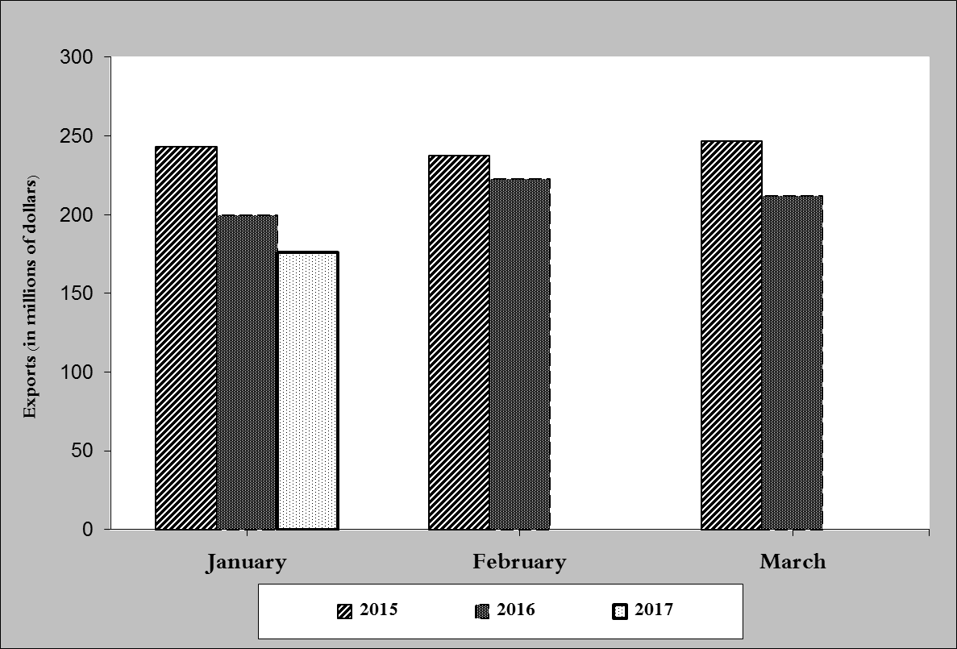

**Chart 1: Industrial exports during years 2015-2016-2017**

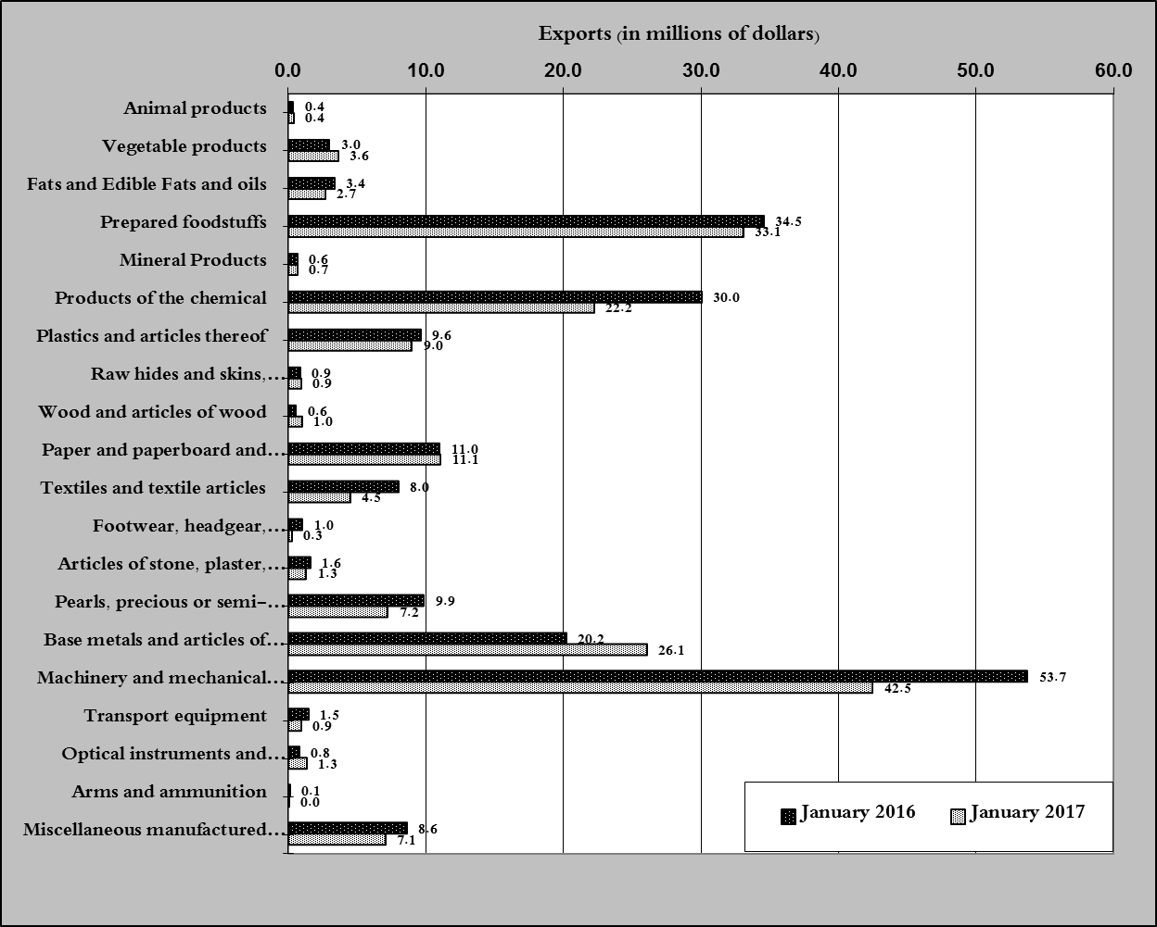

**Chart 2: Comparison of industrial exports during January 2017 and January 2016**

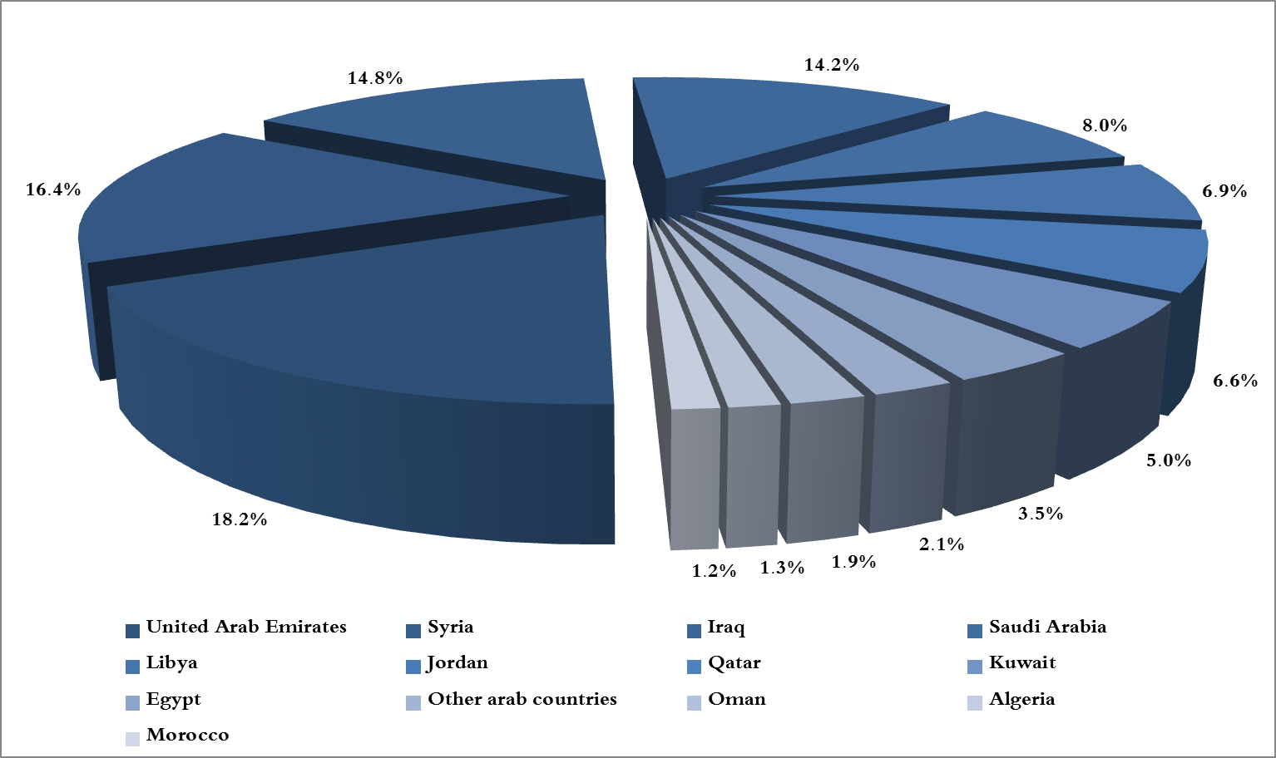

**Chart 3: Distribution of industrial exports to Arab countries during January 2017**

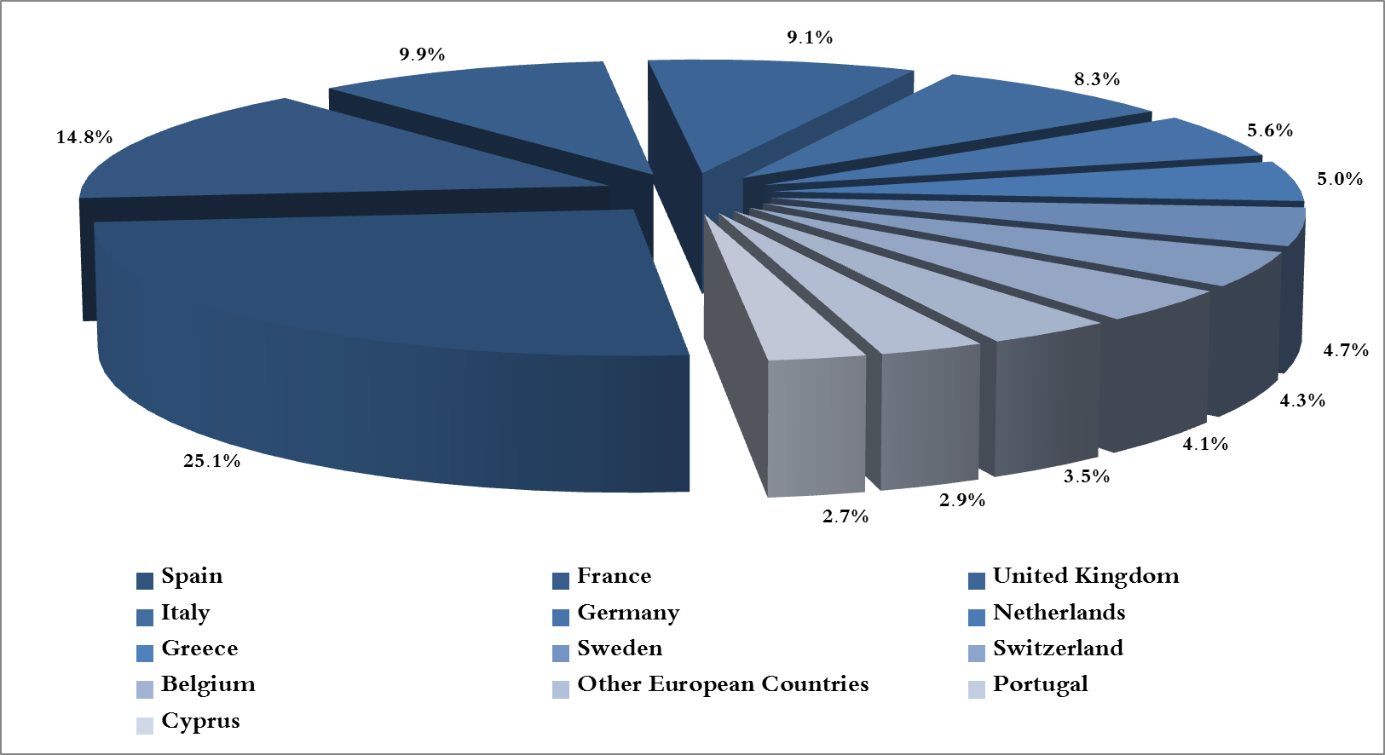

**Chart 4: Distribution of industrial exports to European countries during January 2017**

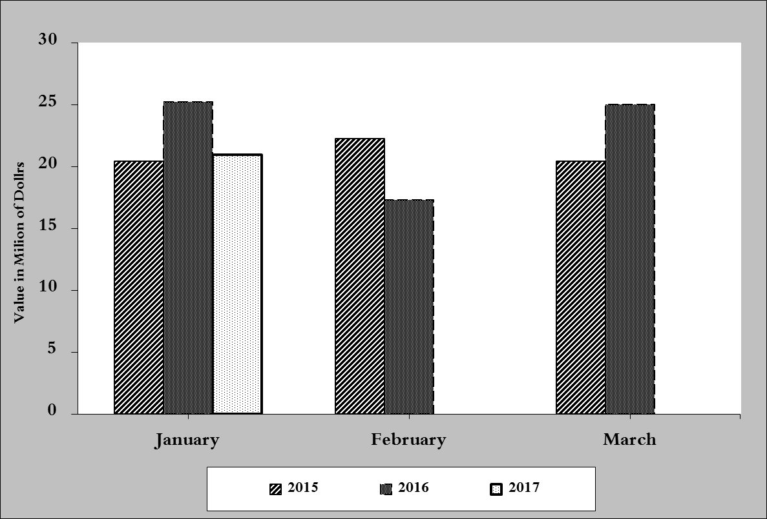

**Chart 5: Imports of industrial machinery and equipment during years 2015-2016-2017**

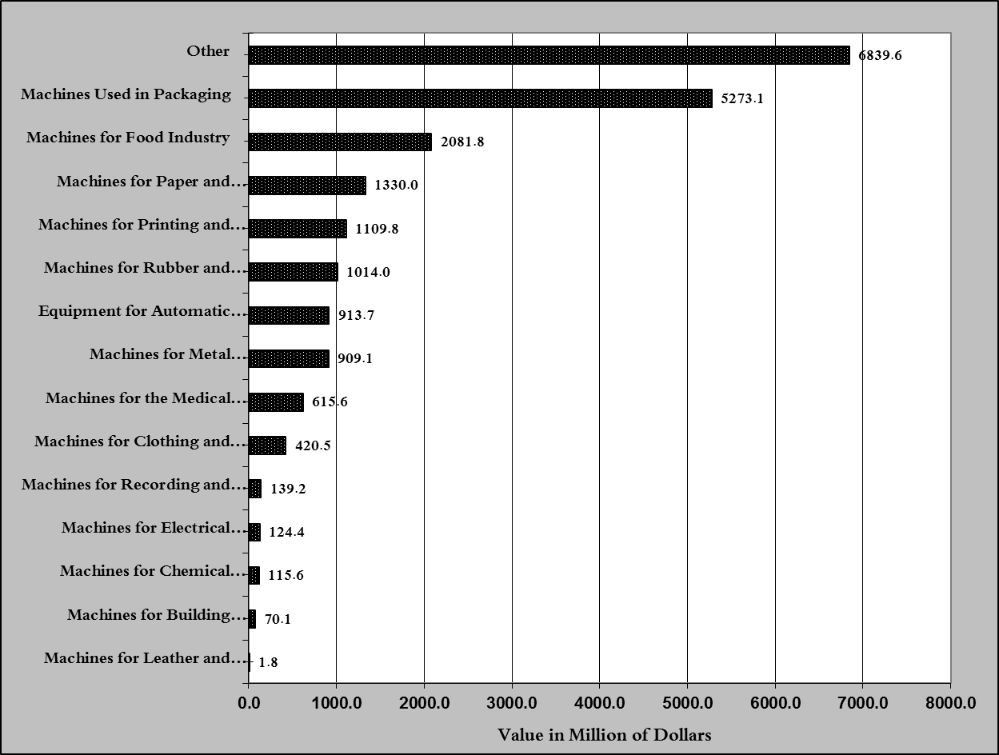

**Chart 6: Imports of industrial equipment and machinery according to industrial activity during January 2017**

1. **Excluding unworked Diamonds, Silver and Gold Ingots which reached this month a value of 64.4 million USD** 
2. **The machineries and equipment are classified in this table according to the industrial sectors that are used in, while heading "other" includes machineries and equipment that can be used in various sectors.**